V.S.B. ENGINEERING COLLEGE, KARUR DEPARTMENT OF COMPUTER SCIENCE AND ENGINEERING

IBM NALAIYA THIRAN PROJECT REPORT

1. INTRODUCTION

Detection and recognition of plant diseases using machine learning are very efficient in providing symptoms of identifying diseases at its earliest. Plant pathologists can analyze the digital images using digital image processing for diagnosis of plant diseases. Application of computer vision and image processing strategies simply assist farmers in all of the regions of agriculture. Generally, the plant diseases are caused by the abnormal physiological functionalities of plants. Therefore, the characteristic symptoms are generated based on the differentiation between normal physiological functionalities and abnormal physiological functionalities of the plants. Mostly, the plant leaf diseases are caused by Pathogens which are positioned on the stems of the plants. These different symptoms and diseases of leaves are predicted by different methods in image processing. These different methods include different fundamental processes like segmentation, feature extraction and classification and so on. Mostly, the prediction and diagnosis of leaf diseases are depending on the segmentation such as segmenting the healthy tissues from diseased tissues of leaves.

Agriculture is the most important sector in today’s life. Most plants are affected by a wide variety of bacterial and fungal diseases. Diseases on plants placed a major constraint on the production and a major threat to food security. Hence, early and accurate identification of plant diseases is essential to ensure high quantity and best quality. In recent years, the number of diseases on plants and the degree of harm caused has increased due to the variation in pathogen varieties, changes in cultivation methods, and inadequate plant protection techniques.

An automated system is introduced to identify different diseases on plants by checking the symptoms shown on the leaves of the plant. Deep learning techniques are used to identify the diseases and suggest the precautions that can be taken for those diseases.

* 1. **PROJECT OVERVIEW**

Overview In this project, two datasets name fruit dataset and vegetable dataset are collected. The collected datasets are trained and tested with deep learning neural network named Convolutional Neural Networks (CNN). First, the fruit dataset is trained and then tested with CNN. It has 6 classes and all the classes are trained and tested. Second, the vegetable dataset is trained and tested. The software used for training and testing of datasets is Python. All the Python codes are first written in Jupyter notebook supplied along with Anaconda Python and then the codes are tested in IBM cloud. Finally, a web-based framework is designed with help Flask a Python library. There are 2 html files are created in templates folder along with their associated files in static folder. The Python program 'app.py' used to interface with these two webpages is written in Spyder-Anaconda python and tested.

* Pre-process the images.
* Applying the CNN algorithm to the dataset.
* How deep neural networks detect the disease.
* You will be able to know how to find the accuracy of the model.
* You will be able to build web applications using the Flask framework.

Create a system for predicting crops according to soil details, predicting fertilizers according to soil and crop details, and detecting diseases in the plant. The objective of our system is to help farmers because it's difficult to grow interventions. Each control approach is then accompanied with the aid of using danger nodes representing unsure occasions (i.e., ‘disorder free’ or ‘dead’, with a view to having possibilities connected to them. Finally, endpoints of DTs are represented with the aid of using a terminal node (triangle) on the proper of the tree. The final results measures (e.g., software value) are usually connected to those endpoints. Costs, however, are connected to occasions in the tree, in addition to endpoints. The anticipated values (expenses and effectiveness) related to every department are expected with the aid of using ‘averaging out’ and ‘folding back’ the tree from proper to left.

**1.2 PURPOSE**

This project is used to test the fruits and vegetables samples and identify the different diseases. Also, this project recommends fertilizers for predicted diseases. In day-to-day life, Agriculture is the most important sector. Most plants are affected by a wide variety of bacterial and fungal diseases. Farmers face several challenges when growing crops like uncertain irrigation, poor soil quality, etc. Especially in India, a major fraction of farmers does not have the knowledge to select appropriate crops and fertilizers. Mostly, the plant leaf diseases are caused by Pathogens which are positioned on the stems of the plants. These different symptoms and diseases of leaves are predicted by different methods in image processing. These different methods include different fundamental processes like segmentation, feature extraction and classification and so on. Mostly, the prediction and diagnosis of leaf diseases are depending on the segmentation such as segmenting the healthy tissues from diseased tissues of leaves Moreover, crop failure due to disease causes a significant loss to the farmers, as well as the consumers. While there have been recent developments in the automated detection of these diseases using Machine Learning techniques, the utilization of Deep Learning has not been fully explored. Additionally, such models are not easy to use because of the high-quality data used in their training, lack of computational power, and poor generalizability of the models. To this end, we create an open- source easy-to-use web application to address some of these issues which may help improve crop production. In particular, we support crop recommendation, fertilizer recommendation, plant disease prediction, and an interactive news-feed. In addition, we also use interpretability techniques in an attempt to explain the prediction made by our disease detection model.

**2.** **LITERATURE SURVEY**

Numerous articles have been reviewed and their conclusions are summarized in this section. This section presents documents that were studied before and during project development. The documents provided a better understanding of existing solutions, how algorithms could be optimized and how selection could be facilitated algorithms on the basis of their performance.

**2.1 EXISTING PROBLEM**

The author says that in India, the largest source of subsistence is agriculture and its federated sectors. In rural regions, there are about 82% of small and marginal farmers, and 70% of rural households depend primarily on agriculture only. The proposed system recommends the suitable crops for the lands with varied soil nutrients. The appropriate fertilizers that are suitable for specific soil nutrient and crop sown are also recommended. Plant physiology can be damaged due to fungal, viral or bacterial diseases. Plants affected from the above pathogens are detected. Random forest classifier gives an accuracy of 98% for recommendation system, and PyTorch neural network gives an accuracy of 99.2% for disease prediction [1]. The Author states that Agriculture is the main aspect for the economic development of a country. Agriculture is the heart and life of most Indians. The soil type, fertilizer recommendation, diseases in plants and leaves. Plant disease, especially on leaves, is one of the major

factors that reduce the yield in both quality and quantity of the food crops. Finding the leaf disease is an important role to preserve agriculture. Smart analysis and Comprehensive prediction model in agriculture helps the farmer to yield right crop at the right time. The main benefits of the proposed system are as follows: Yield right crop at the right time, Balancing the crop production, control plant disease, Economic growth, and planning to reduce the crop scarcity. Hence to Detect and recognize the plant diseases and to recommend fertilizer it is necessary to provide symptoms in identifying the disease at its earliest [2]. The Author claims that Agriculture is the mainstay of a rising economy in India. Traditionally farmers followed ancestral farming patterns and norms. However, a single farmer cannot be expected to take into account all innumerable factors that contribute to crop growth. A single misguided or imprudent decision by the farmer can have undesirable ramifications. With the advancements in various domains, intelligent agricultural system is needed for upliftment of Indian economy. The collaboration of recommender system with machine learning will lead to Intelligent Agriculture System that helps the farmer community in their decision making of farm management and agribusiness activities such as

1. Predicting agriculture commodity market price before cultivation,
2. Determining best cultivars to plant
3. Determine optimum cultivation date
4. Evaluate demand and supply risk
5. Investment Prioritizing. It also helps farmer to perform the activities like crop management including applications on yield prediction, disease detection, weed detection, crop quality, and growth prediction etc. This chapter describes the case study on “Crop Disease Detection and Yield prediction”. The study includes identification of crop condition, disease detection, prediction about specific crop and recommendation using machine learning algorithms. It gives an idea about how recommender system is used in agriculture for disease detection and prediction [3].

**2.2 REFERENCE**

[1] SuriyaKrishnaan, K., Kumar, L. C., & Vignesh, R. (2022). Recommendation System for Agriculture Using Machine Learning and Deep Learning. In Inventive Systems and Control (pp. 625-635). Springer, Singapore.

[2] Selvi, P. P., & Poornima, P. Soil Based Fertilizer Recommendation System for Crop Disease Prediction System.

[3] Akulwar, P. (2020). A recommended system for crop disease detection and yield prediction using machine learning approach. Recommender System with Machine Learning and Artificial Intelligence: Practical Tools and Applications in Medical, Agricultural and Other Industries, 141-163.

**2.3 PROBLEM STATEMENT DEFINITION**

In this project work, a deep learning based neural network is used to train the collected datasets and test the same. The deep learning based neural network is CNN which gives more than 90% classification accuracies. By increasing Image Preprocessing Image dataset collection Image dataset training Build & Save Mode Predict the test dataset the more number of dense layers and by modifying hyperparameters such as number of epochs, batch size, the accuracy rate can be increased to 95% to 98%.

Farmers' conventional methods of agricultural cultivation are ineffective. It does not make proper use of all available resources. Farmers are unable to detect crop diseases due to a lack of knowledge and old practices, which often result in soil nutrient deterioration and exhaustion. As a result, crop failure occurs. Growing only certain crops depletes the soil, and if the crops are harmed by illnesses, farmers are uninformed of how to recover such crops. Food needs cannot be met until and unless efficient resource management and use is implemented.

Suggesting the best compost for each specific harvest is likewise a difficult undertaking. Furthermore, the other and most significant issue is the point at which a plant gets found out by heterogeneous sicknesses that impact on less measure of horticulture creation and compromises with quality too.

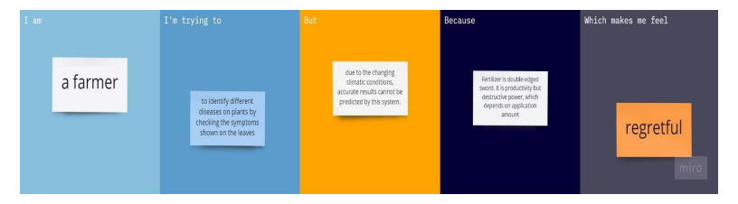

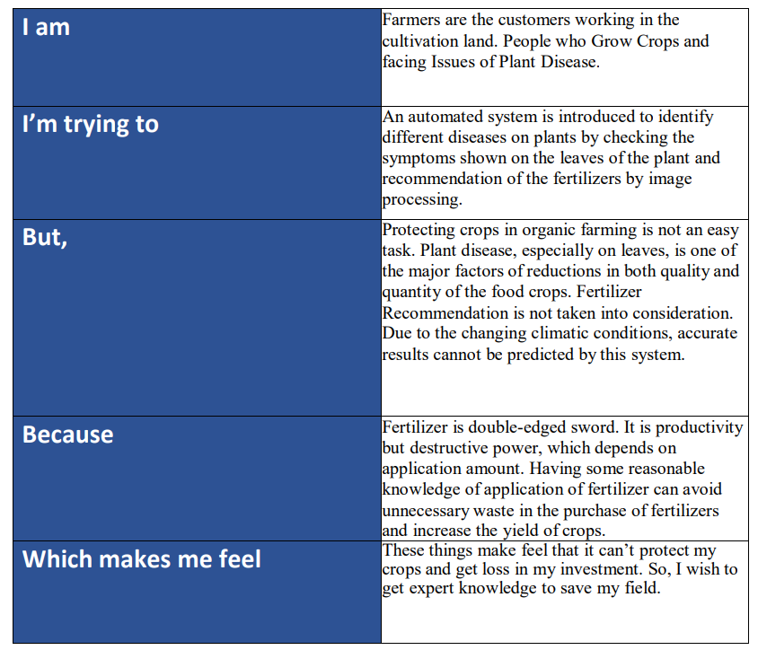

3. IDEATION & PROPOSED SOLUTION

3.1 EMPATHY MAP CANVAS

An empathy map is a collaborative tool teams can use to gain a deeper insight into their customers. Much like a user persona, an empathy map can represent a group of users, such as a customer segment.

Agriculture is the main aspect of the economic development of a country. Agriculture is the heart and life of most Indians. By understanding their feelings and problems, we can create a better product and contribute to their lives. For our project, we are getting surveys from farmers to understand what they truly require and desire.

In addition to being essential to the economy, agriculture is seen as the foundation of the economic system in developing nations. In India, the agriculture and related sectors employ 54.6% of the total labour force. We are building a method based on a survey of home farmers and farmers to increase agriculture efficiency and alleviate challenges faced by both farmers and those engaged in this activity.

**EMPATHY MAP**

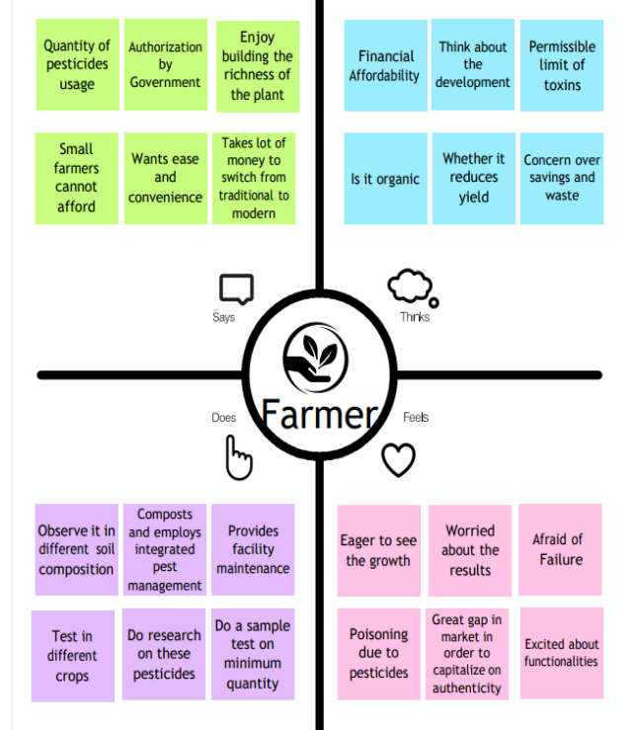

**3.2 IDEATION & BRAINSTROMING**

Brainstorming provides a free and open environment that encourages everyone within a team to participate in the creative thinking process that leads to problem solving. Prioritizing volume over value, out-of-the-box ideas are welcome and built upon, and all participants are encouraged to collaborate, helping each other develop a rich number of creative solutions.

Brainstorming is one of the primary methods employed during the Ideation stage of a typical Design Thinking process. Brainstorming is a great way to generate many ideas by leveraging the collective thinking of the group, engaging with each other, listening, and building on other ideas.

**Step-1: Team Gathering, Collaboration and Select the Problem Statement**

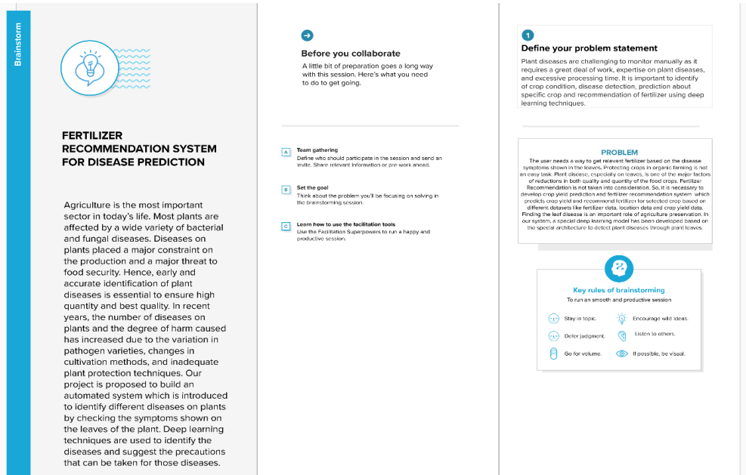

**Step-2: Brainstorm, Idea Listing and Grouping**

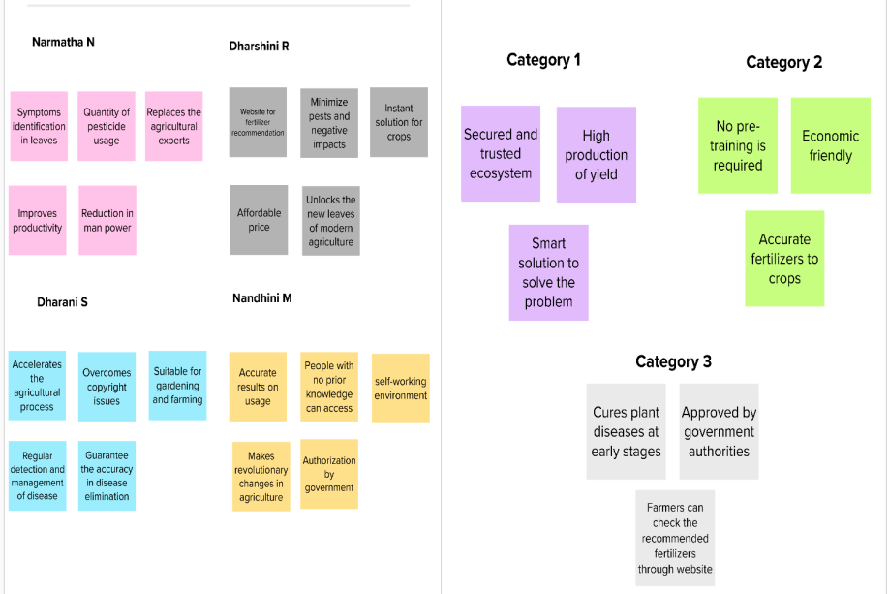

**Step-3: Idea Prioritization**

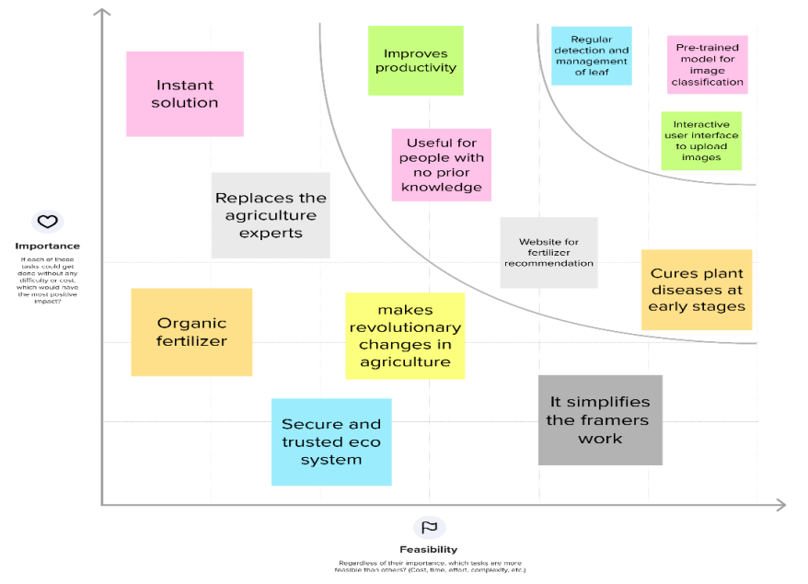

**3.3 PROPOSED SOLUTION**

|  |  |  |
| --- | --- | --- |
| **S.No.** | **Parameter** | **Description** |
| 1. | Problem Statement (Problem to be solved) | Agriculture is the most important sector in today’s life. Most plants are affected by a wide variety of bacterial and fungal diseases. Diseases on plants placed a major constraint on the production and a major threat to food security. Hence, early and accurate identification of plant diseases is essential to ensure high quantity and best quality. In recent years, the number of diseases on plants and the degree of harm caused has increased due to the variation in pathogen varieties, changes in cultivation methods, and inadequate plant protection techniques. Our project is proposed to build an automated system which is introduced to identify different diseases on plants by checking the symptoms shown on the leaves of the plant. Deep learning techniques are used to identify the diseases and suggest the precautions that can be taken for those diseases. |
| 2. | Idea / Solution description | The user needs a way to get relevant fertilizer based on the disease symptoms shown in the leaves. Protecting crops in organic farming is not an easy task. Plant disease, especially on leaves, is one of the major factors of reductions in both quality and quantity of the food crops. Fertilizer Recommendation is not taken into consideration. So, it is necessary to develop crop yield prediction and fertilizer recommendation system which predicts crop yield and recommend fertilizer for selected crop based on different datasets like fertilizer data, location data and crop yield data. |
| 3. | Novelty / Uniqueness | Image data augmentation is a technique that can be used to artificially expand the size of a training dataset by creating modified versions of images in the dataset. Recommend the fertilizer for affected leaves based on severity level.  Fertilizers may be organic or inorganic. Admin can store the fertilizers based on disease categorization with severity levels. The field of agriculture is in a great threat this includes the diseases that attack the plant leaves. Our system finds the area of the leaf that has been affected and also the disease that attacked the leaves. A system that automatically detects leaf disease with the help of image processing is being developed. This system does few image pre- processing techniques like image acquisition, image segmentation, feature extraction and classification. |
| 4. | Social Impact / Customer Satisfaction | User friendly application, the customers are satisfied as we use different methods include different fundamental processes like segmentation, feature extraction and classification and so on. Mostly, the prediction and diagnosis of leaf diseases are depending on the segmentation such as segmenting the healthy tissues from diseased tissues of leaves, so the farmers get high yield. |
| 5. | Business Model (Revenue Model) | Making the business model strong leads to an early identification of disease and the fertilizer is recommended. Crop Yield Prediction can be done using crop yield data, nutrients. Fertilizers can support rolling out beneficial improvements in cultivating by expanding crop yield. Farmers can diminish costs per unit of creation and increment the edge of return over absolute expense by expanding paces of use of fertilizer on chief money and feed crops. This not simply offers huge benefits for farmer jobs and food security, however also conveys natural benefits by diminishing our solicitations for farmland. |
| 6. | Scalability of the Solution | This model reflects different approaches to recognize the illnesses in crops. This model focuses on detecting the plant disease and providing suitable fertilizer which is used for accurate treatment of diseases on crops to provide high quantity and improved quality of products. |

**3.4 PROBLEM SOLUTION FIT**

**1. CUSTOMER SEGMENT(S)**

Farmers are the customers who are unable to identify fertilizers needed for the affected plants.

**2. JOBS-TO-BE-DONE / PROBLEMS**

Using AI Technology diagnose and identify the symptoms of disease in plants regularly and provide the right solution at right time.

**3. TRIGGERS**

Advertising the fertilizer for disease prediction through the social media. Conducting the awareness program and displaying the types of plant diseases and their remedies.

**4. EMOTIONS: BEFORE / AFTER**

Through traditional farming, farmers do not predict the future but in AI farming farmers can predict the future and get high yield.

**5. AVAILABLE SOLUTIONS**

First, we should identify the disease of the leaf and it causes. The measurements of the fertilizer should be suggested based on the severity of the disease and based on the soil.

**6. CUSTOMER CONSTRAINTS**

Cost of Fertilizer is high. Using of not suitable fertilizer can harm the plant and environment.

**7. BEHAVIOUR**

By addressing the Problem, they can get the high yield by utilizing the correct amount of fertilizer according to the leaf disease and the surrounding factors.

**8. CHANNELS of BEHAVIOUR**

**8.1 ONLINE** With the help of the helpline number farmer can get clarify about the queries.

**8.2 OFFLINE** By consulting with expert people farmers can get help.

**9. PROBLEM ROOT CAUSE**

There is no proper guidance for the farmer to prevent the leaf from dreadful diseases.

**10. YOUR SOLUTION**

The customers are unable to identify the disease in plants and feel fear to utilize the fertilizer by think that can harm their environment and fails to yield high. To overcome the farmers problem we use Artificial Intelligence to predict the problem automatically and report the problem. So that we can prevent the disease at early stages and by suggesting the required amount of fertilizes which leads to high yield.

**4. REQUIREMENT ANALYSIS**

There are two types of requirement analysis, namely

1. Functional Requirements
2. Non-functional Requirements

**4.1 FUNCTIONAL REQUIREMENTS**

Following are the functional requirements of the proposed solution.

|  |  |  |
| --- | --- | --- |
| **FR**  **No.** | **Functional Requirement (Epic)** | **Sub Requirement (Story / Sub-Task)** |
| FR-1 | User Registration | Registration through Form Registration through Gmail Registration through Website |
| FR-2 | User Confirmation | Confirmation via Email Confirmation via OTP Confirmation via Message |
| FR-3 | User Requirements | Get the requirements for the farmers’ plants. Capture the image of the leaf And check the parameter of the captured image. |
| FR-4 | User establishment | Establish the good recommendation of fertilizers using the requirements. Upload the image for the prediction and predict the disease in leaf. |
| FR 5 | User review | Suggesting the best fertilizer for the disease. |

**4.2 NON-FUNCTIONAL REQUIREMENTS**

Following are the Non-functional requirements of the proposed solution.

|  |  |  |
| --- | --- | --- |
| **FR**  **No.** | **Non-Functional Requirement** | **Description** |
| NFR-1 | **Usability** | Predicting the fertilizers, Analyzing the disease in a tap makes the life of farmers easy with minimal subscriptions. It detects many diseases in crops and recommends appropriate fertilizers to help them recover. It gives farmers vital information about farming techniques to assist them to enhance crop productivity. Datasets of all the leaf is used to detecting the disease that present in the leaf. |
| NFR-2 | **Security** | Armed with sensors and other monitoring devices, the present farmers can oversee field conditions without going to the homestead. The information belongs to the user and leaves are secured highly. |
| NFR-3 | **Reliability** | For constant admittance to in-handle information, network unwavering quality is critical. With regards to maintainable agribusiness, this nullifies the motivation behind accuracy brilliant cultivating, which depends on the most cutting-edge information and constant natural observing. The leaf quality is important for the predicting the disease in leaf. |
| NFR-4 | **Performance** | The performance is based on the quality of the leaf used for disease prediction. It mainly provides better performance so it helps in high productivity and ensures the attack of disease. |
| NFR-5 | **Availability** | It is available for all users to predict the disease in the plant. This assists ranchers with working on the nature of their items as well as the accessibility, bring down their expenses, and increment the client experience. |
| NFR-6 | **Scalability** | Increasing the prediction of the disease in the leaf. The versatility of a framework to expand the limit, for instance. |

**5. PROJECT DESIGN**

**5.1 DATA FLOW DIAGRAM**

A Data Flow Diagram (DFD) is a traditional visual representation of the information flows within a system. A neat and clear DFD can depict the right amount of the system requirement graphically. It shows how data enters and leaves the system, what changes the information, and where data is stored.

**Example: (Simplified)**

**DIAGRAM**

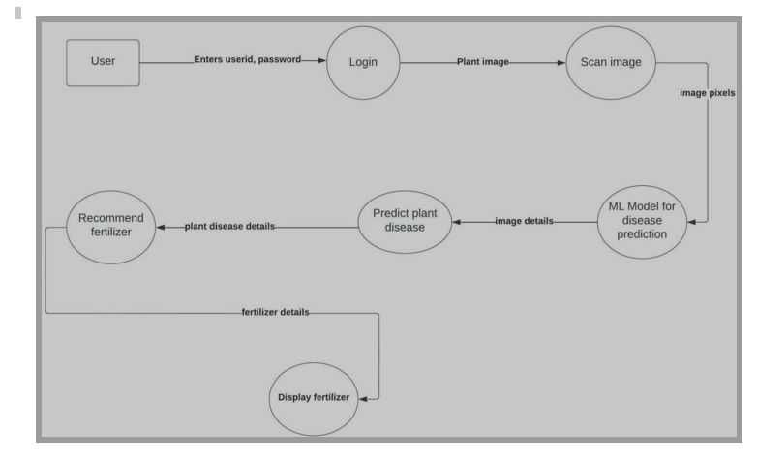

**5.2 SOLUTION AND TECHNICAL ARCHITECTURE:**

**SOLUTION ARCHITECTURE:**

Solution architecture is a complex process – with many sub-processes – that bridges the gap between business problems and technology solutions. Its goals are to:

• Predicting the fertilizers, Analyzing the disease in a tap makes the life of farmers easy with minimal subscriptions would provide an acceptable return for the organization. This action adds a lot of value to the company and the business in society.

• The device is created primarily for farmers. It detects many diseases in crops and recommends appropriate fertilizers to help them recover. It gives farmers vital information about farming techniques to assist them to enhance crop productivity.

• Providing a fertilizer recommendation system to enrich the soil and improve land productivity and system is evaluated by using appropriate timing and accuracy measures.

• Analyze data on symptoms, disease types, and medical treatments to provide the best solution for treating diseases. By providing the construction of a recommendation system that facilitates the identification of pest and the selection of suitable treatments.

• This depicts some promising results to present enhanced methods and tools for creating fully automated pest identification including the extraction with detection.

• Plants nowadays are affected by many diseases such as they cause devastating economic, social and ecological losses and many more. Hence, it is most important to identify plants disease in an accurate and timely way. Plant diseases can be extensively grouped by the idea of their essential causal operator, either irresistible or non-infectious.

**Solution Architecture Diagram:**

**Fertilizers Recommendation System for Disease Prediction**

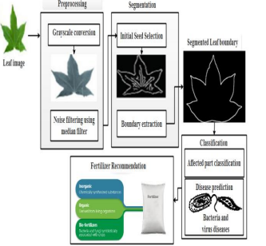

**Different approaches for the identification of leaf diseases**

**\**

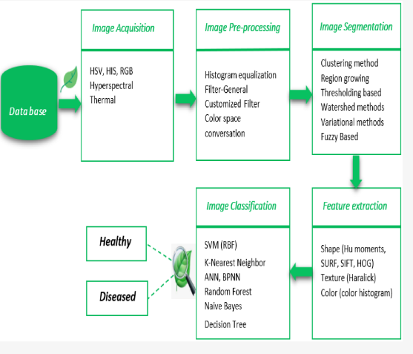

**TECHNICAL ARCHITECTURE:**

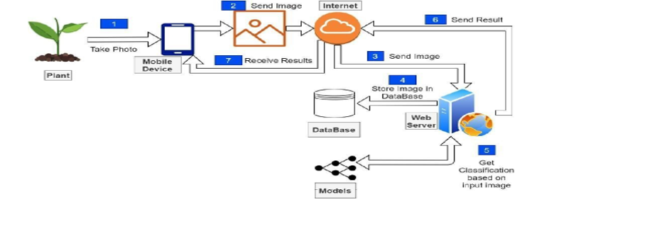

**5.3 USER STORIES** 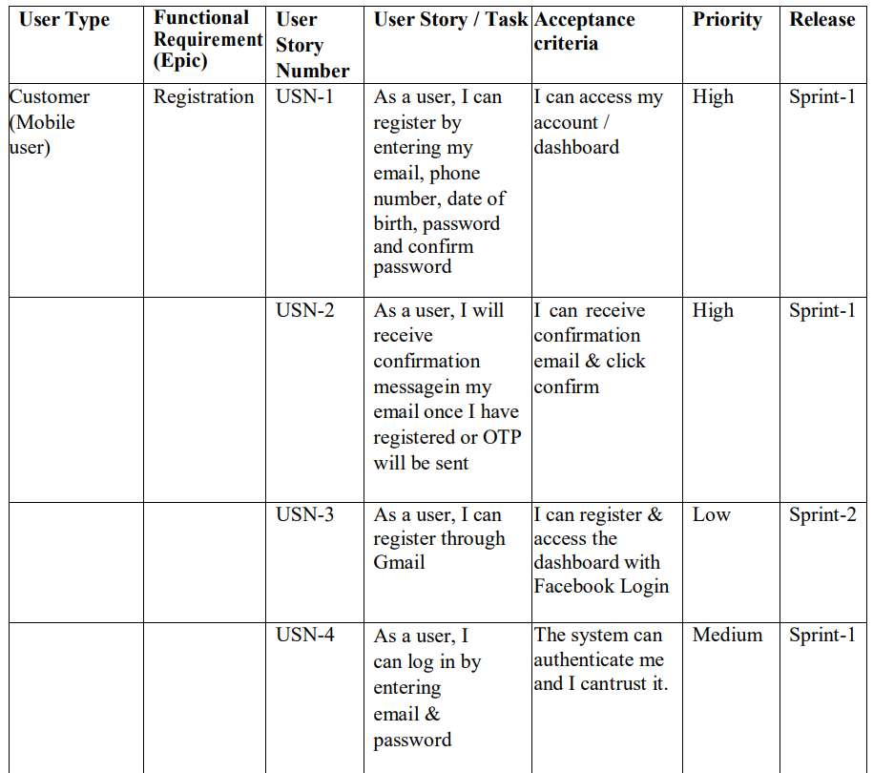

|  |
| --- |
|  |

|  |  |  |  |  |  |  |
| --- | --- | --- | --- | --- | --- | --- |
|  | Login | USN-5 | As a user, I can log into the application by entering email & password. | The system can remember me and save the data. | High | Sprint-1 |
|  | Dashboard | USN-6 | Enter the password and mail ID to login the dashboard. | To view the updates and what are the changes are to be done. | Medium | Sprint-1 |
| Customer (Web user) | Forgot password | USN-1 | Suppose a user forgot password by clicking forgot password and OTP send to my number or mail. | By entering the OTP sent via phone number or email. | High | Sprint-1 |
| Customer Care Executive | Professional responsible. | USN-1 | As a customer care executive, I’m the responsible for communicating the how’s and why’s regarding service exceptions within a company. | Answering phones, responding to customer questions and assisting with customer issues. | High | Sprint-1 |
| Administrator | Login | USN-1 | As an admin I can login by using mail id and password. | Preparing, organizing and storing information in  paper and digital form. | High | Sprint-1 |
|  | Data collection | USN-2 | As an admin, I can upload the data set to train the device. | Dealing with queries on the phone and by email.  Arranging  post and deliveries | High | Sprint-1 |

**6. PROJECT PLANNING & SCHEDULING**

**6.1 SPRINT PLANNING AND ESTIMATION**

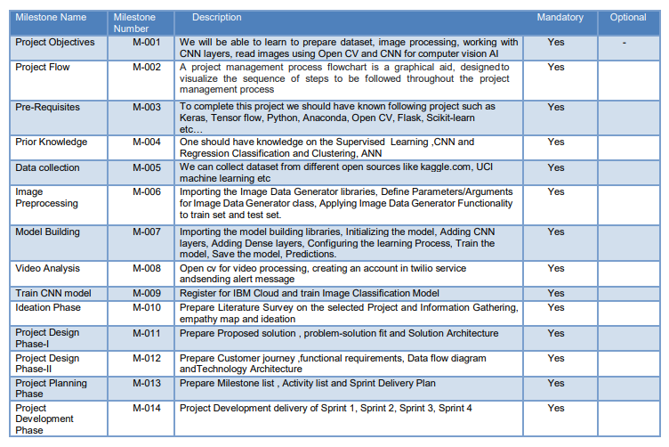

**6.2 SPRINT DELIVERY SCHECDULE**

|  |  |  |  |  |  |  |  |  |  |  |  |  |
| --- | --- | --- | --- | --- | --- | --- | --- | --- | --- | --- | --- | --- |
| **Sprint** | | **Functional Requirement (Epic)** | | **User Story Number** | | **User Story / Task** | | **Story Points** | | **Priority** | | **Team Member** |
| Sprint-1 | | Data collection and preprocessing | | USN-1 | | Collecting plant disease dataset | | 2 | | Low | | Anupriya A |
| Sprint-1 | |  | | USN-2 | | Labelling the dataset according to class | | 3 | | Medium | | Bindu S |
| Sprint-1 | |  | | USN-3 | | 38 types of plant diseases is labeled accordingly | | 2 | | Medium | | Devi Prabha M |
| Sprint-1 | |  | | USN-4 | | Data set Will contain both healthy and diseased data | | 1 | | Low | | Dhaarani S | |
| Sprint-1 | | Preprocessing | | USN-5 | | To prepare raw data in a format that the network can accept | | 2 | | High | | Bindu S | |
| Sprint-1 | |  | | USN-8 | | Zoom Augment will randomly zoom the image and adds new pixels for the image | | 3 | | High | | Bindu S  Dhaarani S | |
| Sprint-1 | |  | | USA-9 | | Flipping the entire pixels of an image horizontally | | 3 | | High | | Devi Prabha M  Dhaarani S | |
| Sprint-2 | | Training, Testing and Creating a model | | USN-10 | | Start initiating the model | | 3 | | Medium | | Bindu S  Devi Prabha M | |
| Sprint-2 | |  | | USN-11 | | Adding different layers of CNN (convolution, pooling dense, flatten) | | 2 | | Medium | | Dhaarani S | |
| Sprint-2 | |  | | USN-12 | | Creating/compiling with Adam optimizer | | 1 | | Medium | | Anupriya A | |
| Sprint-2 | |  | | USN-13 | | Kera’s Categorical Cross Entropy Loss Function for multi-class classification | | 2 | | Medium | | Devi Prabha M | |
| Sprint-2 | |  | | USN-14 | | creating metrics | | 2 | | Medium | | Bindu S | |
| Sprint-2 | |  | | USN-15 | | train the data with 20epoch | | 3 | | High | | Anupriya A  Devi Prabha M | |
| Sprint-2 | |  | | USN-16 | | testing the model | | 5 | | High | | Dhaarani S  Devi Prabha M  Bindu S | |
| Sprint-2 | |  | | USN-17 | | save the model | | 2 | | Medium | | Anupriya A | |
| Sprint-3 | | Flask and Frame work design | | USN-18 | | Creating backend framework with flask | | 8 | | High | | Dhaarani S  Devi Prabha M Bindu S | |
| Sprint-3 | |  | | USN-19 | | importing the model file | | 3 | | Medium | | Devi Prabha M | |
| Sprint-3 | |  | | USN-20 | | Create route to link HTML Routes and View Functions in Flask Framework index file | | 5 | | High | | Dhaarani S  Bindu S | |
| Sprint-3 | |  | | USN-21 | | Server Startup, requests and services in a loop | | 4 | | Medium | | Anupriya A  Devi Prabha M | |
| Sprint-4 | | Front end web application development | | USN-22 | | creating a html template with CSS file | | 8 | | High | | Anupriya A  Dhaarani S  Devi Prabha M Bindu S | |
| Sprint-4 | |  | | USN-23 | | user can import diseased plant leaf in web page | | 2 | | Medium | | Anupriya A  Dhaarani S  Devi Prabha M Bindu S | |
| Sprint-4 | |  | | USN-24 | | predicting what is the type of disease occurred for the given input | | 2 | | Medium | | Devi Prabha M  Dhaarani S | |
| Sprint-4 | |  | | USN-25 | | User can classify as healthy or diseased | | 2 | | Medium | | Anupriya A  Bindu S | |
| Sprint-4 | |  | | USN-26 | | if plant has disease, then suggest fertilizer and pesticides | | 3 | | Medium | | Devi Prabha M  Bindu S | |
| Sprint-4 | |  | | USN-27 | | alert the admin about the prediction with the Gmail | | 3 | | Medium | | Anupriya A | |

**6.3 REPORTS FROM JIRA**

RoadMap:

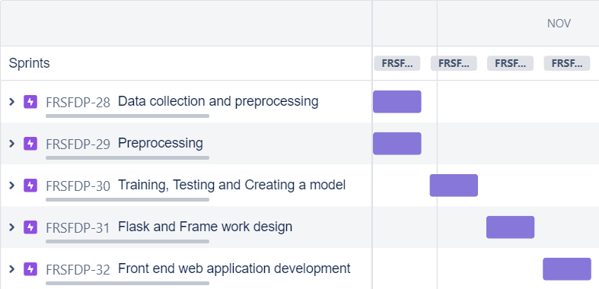

**7. CODING & SOLUTIONING (Explain the features added in the project along with code)**

**7.1 Feature 1**

In this project Fertilizers Recommendation System for Disease Prediction.The proposed method **u**ses SVM to classify tree leaves, identify the disease and suggest the fertilizer. The proposed method is compared with the existing CNN based leaf disease prediction. The proposed SVM technique gives a better result when compared to existing CNN.

We proposed model in this project work can be extended to image recognition. The entire model can be converted to application software using python to exe software. The real time image classiﬁcation, image recognition and video processing are possible with help OpenCV python library. This project work can be extended for security applications such as ﬁgure print recognition, iris recognition and face recognition.

**7.2 Feature 2**

In this project we train the model in this fertilizer using Artificial Intelligence**.** The entire model can be converted to application software using python to exe software. The real time image classiﬁcation, image recognition and video processing are possible with help OpenCV python library.

In train model we had uploaded the image and we compare the leaves fruits and vegetables we want to compare the disease available in these leaves and rectify the disease using Artificial Intelligence.

**7.3 Database Schema (if Applicable)**

In this project we using HTML file for designing the webpage to understand easy to the farmer. In CSS (Cascading Style Sheet) to style the webpage using font and colour and also, we use python for backend.

**8. TESTING**

**8.1 Test Cases**

A test case is a set of actions performed on a system to determine if it satisfies software requirements and functions correctly. For example, a test scenario might be, “**Verify login functionality**.” Test scenarios typically have their own ID numbers for tracking. QA teams often derive test cases (low-level actions) from test scenarios (high-level actions); and test scenarios typically come from software and business requirements documentation.

**Character of test cases:**

* Guaranteed good test coverage.
* Reduced maintenance and software support costs.
* Reusable test cases.
* Confirmation that the software satisfies end-user requirements.
* Improved quality of software and user experience.
* Higher quality products lead to more satisfied customers.
* More satisfied customers will increase company profits.

**8.2 User Acceptance Testing**

1. **Purpose of Document**

The purpose of this document is to briefly explain the test coverage and open issues of the [Fertilizer recommendation system for disease prediction] project at the time of the release to User Acceptance Testing (UAT).

1. **Defect Analysis**

This report shows the number of resolved or closed bugs at each severity level, and how they were resolved.

|  |  |  |  |  |  |
| --- | --- | --- | --- | --- | --- |
| **Resolution** | **Severity 1** | **Severity 2** | **Severity 3** | **Severity 4** | **Subtotal** |
| Yellow Leaves | 10 | 4 | 5 | 15 | 34 |
| Blights | 1 | 5 | 2 | 4 | 12 |
| Fruit rots | 3 | 1 | 0 | 2 | 6 |
| Leaf spots | 9 | 2 | 4 | 18 | 33 |
| Mosaic leaf pattern | 3 | 9 | 6 | 6 | 24 |
| Fruit Spots | 3 | 1 | 5 | 1 | 10 |
| Leaves misshapen | 0 | 7 | 2 | 1 | 10 |
| Totals | 29 | 29 | 24 | 47 | 129 |

1. **Test Case Analysis**

This report shows the number of test cases that have passed, failed, and untested.

|  |  |  |  |  |
| --- | --- | --- | --- | --- |
| **Section** | **Total Cases** | **Not Tested** | **Fail** | **Pass** |
| Yellow Leaves | 20 | 0 | 0 | 20 |
| Blights | 43 | 0 | 0 | 43 |
| Fruit rots | 9 | 0 | 0 | 9 |
| Leaf spots | 5 | 0 | 0 | 5 |
| Mosaic leaf pattern | 19 | 0 | 0 | 19 |
| Fruit Spots | 2 | 0 | 0 | 2 |
| Leaves misshapen | 4 | 0 | 0 | 4 |

**9. RESULTS**

**9.1 Performance Metrics**

**1.Model Summary of  Fruit**

Training the dataset of Vegetable images by using the CNN models to predict the disease of the given leaves.

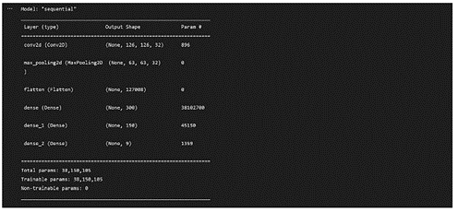

**2.Model Summary for Vegetable**

Training the dataset of Vegetable images by using the CNN models to predict the disease of the given leaves.

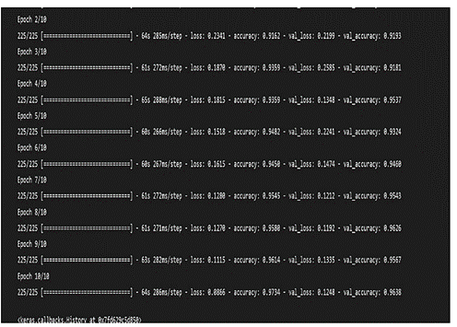

**3.Accuracy for Fruit**

Training Accuracy - 0.9734

Validation Accuracy - 0.9638

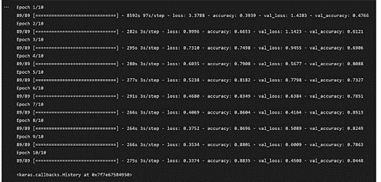

**4.Accuracy for Vegetable**

Training Accuracy - 0.8835

Validation Accuracy - 0.8448

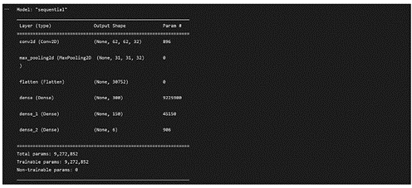

**10. ADVANTAGES & DISADVANTAGES**

**List of advantages**

● The proposed model here produces very high accuracy of classification.

● Very large datasets can also be trained and tested.

● Images of very high can be resized within the proposed itself.

**List of disadvantages**

● For training and testing, the proposed model requires very high computational time.

● The neural network architecture used in this project work has high complexity.

**11. CONCLUSION**

The model proposed here involves image classification of fruit datasets and vegetable datasets. The following points are observed during model testing and training:

● The accuracy of classification increased by increasing the number of epochs.

● For different batch sizes, different classification accuracies are obtained.

● The accuracies are increased by increasing more convolution layers.

● The accuracy of classification also increased by varying dense layers.

● Different accuracies are obtained by varying the size of kernel used in the convolution layer output.

● Accuracies are different while varying the size of the train and test datasets.

**12. FUTURE SCOPE**

The proposed model in this project work can be extended to image recognition. The entire model can be converted to application software using python to exe software. The real time image classification, image recognition and video processing are possible with help OpenCV python library. This project work can be extended for security applications such as figure print recognition, iris recognition and face recognition.

**13. APPENDIX**

**Source Code**

**1_Histogram.ipynb**

import cv2

import matplotlib.pyplot as plt

import numpy as np

img = cv2.imread('/content/drive/MyDrive/0a285c8b-1c31-48d4-89f2-af8b9edc36f6___RS_HL 5759.JPG', 0)

plt.imshow(img, cmap='gray'), plt.grid(False)

plt.xticks([]), plt.yticks([])

hist = cv2.calcHist([img],[0],None,[50],[0,256])

# different methods for displaying a histogram

plt.bar(range(50), hist.ravel())

plt.title('Histogram of the airplane image')

plt.xlabel('Gray values')

plt.ylabel('Frequency')

# Another method

hist,bins = np.histogram(img.ravel(),256,[0,256])

plt.plot(hist)

# Let's read two other images

high = cv2.imread('/content/drive/MyDrive/aa04db6d-645f-4e8a-88dc-c9f9396f0800___RS_HL 1975.jpg')

low = cv2.imread('/content/drive/MyDrive/0a285c8b-1c31-48d4-89f2-af8b9edc36f6___RS_HL 5759.JPG')

# show images

plt.subplot(121), plt.imshow(high)

plt.grid(False), plt.xticks([]), plt.yticks([])

plt.subplot(122), plt.imshow(low)

plt.grid(False), plt.xticks([]), plt.yticks([])

plt.show()

# Calculate histogram of both images for the last channel.

# Channels can differ from 0 to 2.

hist_high = cv2.calcHist([high],[2],None,[256],[0,256])

hist_low = cv2.calcHist([low],[2],None,[256],[0,256])

# Plot histograms

plt.subplot(121)

plt.plot(hist_high)

plt.subplot(122)

plt.plot(hist_low)

plt.show()

cdf_low = hist_low.cumsum()

cdf_high = hist_high.cumsum()

# plot cumulative histograms

plt.subplot(221), plt.plot(cdf_high), plt. title('cdf of bright image')

plt.subplot(222), plt.plot(hist_high, 'k'), plt. title('pdf of bright image')

plt.subplot(223), plt.plot(cdf_low), plt. title('cdf of dark image')

plt.subplot(224), plt.plot(hist_low, 'k'), plt. title('pdf of dark image')

# adjust the placement of subplots

plt.subplots_adjust(bottom=2, right=0.8, top=3)

plt.show()

low_gray = cv2.cvtColor(low, cv2.COLOR_BGR2GRAY)

high_gray = cv2.cvtColor(high, cv2.COLOR_BGR2GRAY)

# show images and their histograms

plt.subplot(221), plt.imshow(high_gray, cmap='gray')

plt.grid(False), plt.xticks([]), plt.yticks([])

plt.subplot(223), plt.plot(cv2.calcHist([high_gray],[0],None,[256],[0,256]))

plt.subplot(222), plt.imshow(low_gray, cmap='gray')

plt.grid(False), plt.xticks([]), plt.yticks([])

plt.subplot(224), plt.plot(cv2.calcHist([low_gray],[0],None,[256],[0,256]))

plt.show()

# Define a function to easily handle manipulation.

def manip_image(image, alpha, beta):

new_image = np.zeros(image.shape, image.dtype)

for y in range(image.shape[0]):

for x in range(image.shape[1]):

new_image[y,x] = np.clip(alpha*image[y,x] + beta, 0, 255)

return new_image

# Test on the image

bright = manip_image(img, 1, 30)

dark = manip_image(img, 1, -30)

# Compare the results

plt.figure()

plt.subplot(231), plt.imshow(dark, cmap='gray')

plt.grid(False), plt.xticks([]), plt.yticks([])

plt.subplot(232), plt.imshow(img, cmap='gray')

plt.grid(False), plt.xticks([]), plt.yticks([])

plt.subplot(233),plt.imshow(bright, cmap='gray')

plt.grid(False), plt.xticks([]), plt.yticks([])

plt.subplot(234)

plt.plot(cv2.calcHist([dark],[0],None,[256],[0,256])), plt.ylim((0, 1750))

plt.subplot(235)

plt.plot(cv2.calcHist([img],[0],None,[256],[0,256]))

plt.subplot(236)

plt.plot(cv2.calcHist([bright],[0],None,[256],[0,256]))

# Test on the dark image

l_bright = manip_image(low_gray, 1, 150)

l_dark = manip_image(low_gray, 1, -25)

# Compare the results

plt.figure()

plt.subplot(231), plt.imshow(l_dark, cmap='gray')

plt.grid(False), plt.xticks([]), plt.yticks([])

plt.subplot(232), plt.imshow(low_gray, cmap='gray')

plt.grid(False), plt.xticks([]), plt.yticks([])

plt.subplot(233),plt.imshow(l_bright, cmap='gray')

plt.grid(False), plt.xticks([]), plt.yticks([])

plt.subplot(234)

plt.plot(cv2.calcHist([l_dark],[0],None,[256],[0,256])), plt.ylim((0, 1100))

plt.subplot(235)

plt.plot(cv2.calcHist([low_gray],[0],None,[256],[0,256])), plt.ylim((0, 1100))

plt.subplot(236)

plt.plot(cv2.calcHist([l_bright],[0],None,[256],[0,256])), plt.ylim((0, 1100))

# Test on the image

increase_contrast = manip_image(img, 1.35, 0)

decrease_contrast = manip_image(img, 0.35, 0)

# Compare the results

plt.figure()

plt.subplot(231), plt.imshow(decrease_contrast, cmap='gray')

plt.grid(False), plt.xticks([]), plt.yticks([])

plt.subplot(232), plt.imshow(img, cmap='gray')

plt.grid(False), plt.xticks([]), plt.yticks([])

plt.subplot(233),plt.imshow(increase_contrast, cmap='gray')

plt.grid(False), plt.xticks([]), plt.yticks([])

plt.subplot(234)

plt.bar(range(256),

cv2.calcHist([decrease_contrast],[0],None,[256],[0,256]).ravel())

plt.ylim((0, 1750))

plt.subplot(235)

plt.bar(range(256),

cv2.calcHist([img],[0],None,[256],[0,256]).ravel())

plt.ylim((0, 1750))

plt.subplot(236)

plt.bar(range(256),

cv2.calcHist([increase_contrast],[0],None,[256],[0,256]).ravel())

plt.ylim((0, 1750))

img_eq = cv2.equalizeHist(img)

grid = plt.GridSpec(3, 4, wspace=0.4, hspace=0.3)

plt.subplot(grid[:2, :2])

plt.imshow(img, cmap='gray')

plt.grid(False), plt.xticks([]), plt.yticks([])

plt.subplot(grid[:2, 2:])

plt.imshow(img_eq, cmap='gray')

plt.grid(False), plt.xticks([]), plt.yticks([])

plt.subplot(grid[2, :2])

plt.bar(range(256),

cv2.calcHist([img],[0],None,[256],[0,256]).ravel())

plt.subplot(grid[2, 2:])

plt.bar(range(256),

cv2.calcHist([img_eq],[0],None,[256],[0,256]).ravel())

clahe = cv2.createCLAHE(clipLimit=2.0, tileGridSize=(16, 16))

img_cl = clahe.apply(img)

grid = plt.GridSpec(3, 4, wspace=0.4, hspace=0.3)

plt.subplot(grid[:2, :2])

plt.imshow(img, cmap='gray')

plt.grid(False), plt.xticks([]), plt.yticks([])

plt.subplot(grid[:2, 2:])

plt.imshow(img_cl, cmap='gray')

plt.grid(False), plt.xticks([]), plt.yticks([])

plt.subplot(grid[2, :2])

plt.bar(range(256),

cv2.calcHist([img],[0],None,[256],[0,256]).ravel())

plt.subplot(grid[2, 2:])

plt.bar(range(256),

cv2.calcHist([img_cl],[0],None,[256],[0,256]).ravel())

**2_Spatial_Filtering.ipynb**

import cv2

import numpy as np

from matplotlib import pyplot as plt

ref = cv2.imread('/content/drive/MyDrive/0a285c8b-1c31-48d4-89f2-af8b9edc36f6___RS_HL 5759.JPG')

plt.imshow(ref), plt.grid(False)

# while learning how to perform spatial filtering,

# you can also note how to apply different python commands.

plt.title('The original image')

plt.xticks([])

plt.yticks([])

plt.show()

# Defining a kernel using numpy.

kernel_5 = np.ones((5,5),np.float32)/25

kernel_3 = np.ones((3,3),np.float32)/9

# Convolves an image with the kernel.

# -1 means that the center of the kernel is located on the center pixel.

# compare two kernel sizes.

filtered_5 = cv2.filter2D(ref,-1,kernel_5)

filtered_3 = cv2.filter2D(ref,-1,kernel_3)

# plot the results in two subplots.

fig=plt.figure(figsize=(14, 14), dpi= 80, facecolor='w', edgecolor='k')

plt.subplot(121), plt.imshow(filtered_3), plt.title('3-by-3 filter')

plt.grid(False)

plt.xticks([])

plt.yticks([])

plt.subplot(122), plt.imshow(filtered_5), plt.title('5-by-5 filter')

plt.grid(False)

plt.xticks([])

plt.yticks([])

plt.show()

# you can check the docs for further information.

blurred = cv2.blur(ref, (5, 5), -1)

plt.imshow(blurred), plt.grid(False), plt.xticks([]), plt.yticks([]), plt.show()

top = 10; bottom = 5; left = 20; right = 5

const = 100

img2 = cv2.copyMakeBorder(ref, top, bottom, left, right,

cv2.BORDER_WRAP)

img3 = cv2.copyMakeBorder(ref, top, bottom, left, right,

cv2.BORDER_REFLECT)

img4 = cv2.copyMakeBorder(ref, top, bottom, left, right,

cv2.BORDER_REPLICATE)

img5 = cv2.copyMakeBorder(ref, top, bottom, left, right,

cv2.BORDER_CONSTANT, const)

# Display the images

fig=plt.figure(figsize=(14, 14), dpi= 80, facecolor='w', edgecolor='k')

plt.subplot(221), plt.imshow(img2), plt.grid(False)

plt.xticks([]), plt.yticks([]), plt.title('wrap')

plt.subplot(222), plt.imshow(img3), plt.grid(False)

plt.xticks([]), plt.yticks([]), plt.title('reflect')

plt.subplot(223), plt.imshow(img4), plt.grid(False)

plt.xticks([]), plt.yticks([]), plt.title('replicate')

plt.subplot(224), plt.imshow(img5), plt.grid(False)

plt.xticks([]), plt.yticks([]), plt.title('constant')

plt.show()

# vertical gradient kernel

# define a random kernel

vertical_gd = np.array([[1, 0, -1], [1, 0, -1], [1, 0, -1]])

# apply it.

filter_v = cv2.filter2D(ref[:, :, 2], -1, vertical_gd)

# show in a different colormap.

plt.imshow(filter_v, cmap='gray'), plt.grid(False)

plt.xticks([]), plt.yticks([])

s_and_p = np.random.rand(ref.shape[0], ref.shape[1])

# if we consider 5% salt and pepper noise, we'd like to have

# 2.5% salt and 2.5% pepper. thus:

salt = s_and_p > .975

pepper = s_and_p < .025

# in order to add some noise, we should turn off black (pepper) locations and

# turn on white (white) locations.

channel_2 = np.atleast_1d(ref[:, :, 1])

noisy = np.zeros_like(channel_2)

for i in range(channel_2.shape[0]*channel_2.shape[1]):

if salt.ravel()[i] == 1:

noisy.ravel()[i] = 255

elif pepper.ravel()[i] == 1:

noisy.ravel()[i] = 0

else:

noisy.ravel()[i] = channel_2.ravel()[i]

# apply median filter with size 3

Med = cv2.medianBlur(noisy, 3)

# Display the results

fig=plt.figure(figsize=(14, 14), dpi= 80, facecolor='w', edgecolor='k')

plt.subplot(121), plt.xticks([]), plt.yticks([])

plt.imshow(noisy, cmap='gray'), plt.grid(False)

plt.subplot(122), plt.xticks([]), plt.yticks([])

plt.imshow(Med, cmap='gray'), plt.grid(False)

plt.show()

# Creating random normal (gaussian) noise with pre-defined mean and std.

# The noisy image should be the size of the reference image.

mean = 0

sigma = 20.0

gauss_noise = np.random.normal(mean, sigma, (ref.shape[0], ref.shape[1]))

# Convert RGB image to Grayscale image using cvtColor()

gray = cv2.cvtColor(ref, cv2.COLOR_BGR2GRAY)

# Add gaussian noise to the image

g_noisy = gray + gauss_noise # Gaussian noisy image

# Showing gray image, noise image, and noisy image

fig=plt.figure(figsize=(14, 14), dpi= 80, facecolor='w', edgecolor='k')

plt.subplot(131), plt.xticks([]), plt.yticks([])

plt.imshow(gray, cmap='gray'), plt.grid(False)

plt.subplot(132), plt.xticks([]), plt.yticks([])

plt.imshow(gauss_noise, cmap='gray'), plt.grid(False)

plt.subplot(133), plt.xticks([]), plt.yticks([])

plt.imshow(g_noisy, cmap='gray'), plt.grid(False)

g_filtered = cv2.GaussianBlur(g_noisy, (3, 3), 20, 20)

# Display the result

plt.imshow(g_filtered, cmap='gray'), plt.grid(False)

plt.xticks([]), plt.yticks([])

# Create a single gaussian kernel

g_kernel = cv2.getGaussianKernel(3, 20)

print(g_kernel)

# Apply two separate kernels over the image.

g_filtered_2 = cv2.sepFilter2D(g_noisy, -1, g_kernel, g_kernel)

# Displaying the results.

fig=plt.figure(figsize=(14, 14), dpi= 80, facecolor='w', edgecolor='k')

plt.subplot(121), plt.xticks([]), plt.yticks([]), plt.title('first method')

plt.imshow(g_filtered, cmap='gray'), plt.grid(False)

plt.subplot(122), plt.xticks([]), plt.yticks([]), plt.title('second method')

plt.imshow(g_filtered_2, cmap='gray'), plt.grid(False)

**3_Intensity_Transformations.ipynb**

from skimage.io import imread

import matplotlib.pyplot as plt

import numpy as np

live = imread('/content/drive/MyDrive/DataSet/Dataset Plant Disease/fruit-dataset/fruit-dataset/test/Apple___Black_rot/0b37761a-de32-47ee-a3a4-e138b97ef542___JR_FrgE.S 2908.JPG')

mask = imread('/content/drive/MyDrive/DataSet/Dataset Plant Disease/fruit-dataset/fruit-dataset/test/Apple___Black_rot/00e909aa-e3ae-4558-9961-336bb0f35db3___JR_FrgE.S 8593.JPG')

plt.figure(figsize=(10, 10))

plt.subplot(121), plt.imshow(live, cmap='gray')

plt.subplot(122), plt.imshow(mask, cmap='gray')

plt.show()

plt.figure(figsize=(10, 10))

plt.subplot(121), plt.imshow(live, cmap='gray')

plt.subplot(122), plt.imshow(live - 20, cmap='gray')

plt.show()

plt.figure(figsize=(10, 10))

plt.subplot(131), plt.imshow(mask - live, cmap='gray')

plt.subplot(132), plt.imshow(-(mask - live + 128), cmap='gray')

plt.subplot(133), plt.imshow(mask - live + 128, cmap='gray')

plt.show()

shaded = imread('/content/drive/MyDrive/DataSet/Dataset Plant Disease/fruit-dataset/fruit-dataset/test/Apple___Black_rot/0b37761a-de32-47ee-a3a4-e138b97ef542___JR_FrgE.S 2908.JPG')

shading = imread('/content/drive/MyDrive/DataSet/Dataset Plant Disease/fruit-dataset/fruit-dataset/test/Apple___Black_rot/00e909aa-e3ae-4558-9961-336bb0f35db3___JR_FrgE.S 8593.JPG')

plt.figure(figsize=(10, 10))

plt.subplot(121), plt.imshow(shaded, cmap='gray')

plt.subplot(122), plt.imshow(shading, cmap='gray')

plt.show()

plt.figure(figsize=(10, 10))

plt.subplot(121), plt.imshow(np.multiply(shaded, 1/shading), cmap='gray')

plt.subplot(122), plt.imshow(shaded, cmap='gray')

plt.show()

# Test on the X-ray dental image

xray = imread('/content/drive/MyDrive/DataSet/Dataset Plant Disease/fruit-dataset/fruit-dataset/test/Apple___Black_rot/00e909aa-e3ae-4558-9961-336bb0f35db3___JR_FrgE.S 8593.JPG')

mask_xray = imread('/content/drive/MyDrive/DataSet/Dataset Plant Disease/fruit-dataset/fruit-dataset/test/Peach___Bacterial_spot/00ddc106-692e-4c67-b2e8-569c924caf49___Rutg._Bact.S 1228.JPG')

plt.figure(figsize=(10, 10))

plt.subplot(121), plt.imshow(xray, cmap='gray')

plt.subplot(122), plt.imshow(mask_xray, cmap='gray')

plt.show()

plt.figure()

plt.imshow(np.multiply(xray, mask_xray/255), cmap='gray')

plt.show()

# Test on another image

scan = imread('/content/drive/MyDrive/DataSet/Dataset Plant Disease/fruit-dataset/fruit-dataset/test/Corn_(maize)___Northern_Leaf_Blight/0a62fe5a-22db-42e2-bca0-53a8dcfd8129___RS_NLB 0810.JPG')

print(scan.shape)

# Showing the body scan image

plt.figure(figsize=(7, 7))

plt.imshow(scan, cmap='gray')

plt.show()

plt.figure(figsize=(10, 10))

plt.subplot(211), plt.imshow(xray, cmap='gray')

plt.subplot(212), plt.plot(np.histogram(xray, bins=256)[0])

plt.show()

Image Preprocessing.ipynb

from keras.preprocessing.image import ImageDataGenerator

train_datagen = ImageDataGenerator (rescale = 1./255, shear_range= 0.2,zoom_range= 0.2, horizontal_flip = True)

test_datagen =ImageDataGenerator (rescale = 1)

x_train = train_datagen.flow_from_directory(r'/content/drive/MyDrive/DataSet/Dataset Plant Disease/fruit-dataset/fruit-dataset/test',target_size = (128,128), batch_size = 32, class_mode = 'categorical')

x_test = test_datagen.flow_from_directory(r'/content/drive/MyDrive/DataSet/Dataset Plant Disease/fruit-dataset/fruit-dataset/train',target_size = (128,128), batch_size = 32, class_mode = 'categorical')

x_train = train_datagen.flow_from_directory(r'/content/drive/MyDrive/DataSet/Dataset Plant Disease/Veg-dataset/Veg-dataset/test_set',target_size = (128,128), batch_size = 32, class_mode = 'categorical')

x_test = test_datagen.flow_from_directory(r'/content/drive/MyDrive/DataSet/Dataset Plant Disease/Veg-dataset/Veg-dataset/test_set',target_size = (128,128), batch_size = 32, class_mode = 'categorical')

**TRAINING THE MODELS**

**FruitData.ipynb**

from tensorflow.keras.preprocessing.image import ImageDataGenerator

from tensorflow.keras.models import Sequential

from tensorflow.keras.layers import Dense,Convolution2D,MaxPooling2D,Flatten

import numpy as np

from tensorflow.keras.models import load_model

from tensorflow.keras.preprocessing import image

train_datagen=ImageDataGenerator(rescale=1./255,zoom_range=0.2,horizontal_flip=True,vertical_flip=False)

test_datagen=ImageDataGenerator(rescale=1./255)

x_train=train_datagen.flow_from_directory(r"/content/drive/MyDrive/DataSet/Dataset Plant Disease/fruit-dataset/fruit-dataset/train",target_size=(128,128),

class_mode='categorical',batch_size=24)

x_test=test_datagen.flow_from_directory(r"/content/drive/MyDrive/DataSet/Dataset Plant Disease/fruit-dataset/fruit-dataset/test",target_size=(128,128),

class_mode='categorical',batch_size=24)

model=Sequential()

model.add(Convolution2D(32,(3,3),input_shape=(128,128,3),activation='relu'))

model.add(MaxPooling2D(pool_size=(2,2)))

model.add(Flatten())

model.summary()

32*(3*3*3+1)

model.add(Dense(300,activation='relu'))

model.add(Dense(150,activation='relu'))

model.add(Dense(6,activation='softmax'))

model.compile(loss='categorical_crossentropy',optimizer='adam',metrics=['accuracy'])

len(x_train)

model.fit(x_train,steps_per_epoch=len(x_train),validation_data=x_test,validation_steps=len(x_test),epochs=10)

model.save('fruitdata.h5')

**Vegetable Data.ipynb**

from tensorflow.keras.preprocessing.image import ImageDataGenerator

from tensorflow.keras.models import Sequential

from tensorflow.keras.layers import Dense,Convolution2D,MaxPooling2D,Flatten

import numpy as np

from tensorflow.keras.models import load_model

from tensorflow.keras.preprocessing import image

train_datagen=ImageDataGenerator(rescale=1./255,zoom_range=0.2,horizontal_flip=True,vertical_flip=False)

test_datagen=ImageDataGenerator(rescale=1./255)

x_train=train_datagen.flow_from_directory(r"/content/drive/MyDrive/DataSet/Dataset Plant Disease/Veg-dataset/Veg-dataset/train_set",target_size=(128,128),

class_mode='categorical',batch_size=24)

x_test=test_datagen.flow_from_directory(r'/content/drive/MyDrive/DataSet/Dataset Plant Disease/Veg-dataset/Veg-dataset/test_set',target_size=(128,128),

class_mode='categorical',batch_size=24)

model=Sequential()

model.add(Convolution2D(32,(3,3),input_shape=(128,128,3),activation='relu'))

model.add(MaxPooling2D(pool_size=(2,2)))

model.add(Flatten())

model.summary()

model.add(Dense(300,activation='relu'))

model.add(Dense(150,activation='relu'))

model.add(Dense(9,activation='softmax'))

model.compile(loss='categorical_crossentropy',optimizer='adam',metrics=['accuracy'])

model.fit(x_train,steps_per_epoch=len(x_train),validation_data=x_test,validation_steps=len(x_test),epochs=10)

model.save('vegetabledata.h5')

**TESTING THE MODELS**

**Tested_fruitdat.ipynb**

import tensorflow as tf

from tensorflow import keras

from tensorflow.keras.preprocessing.image import ImageDataGenerator

import numpy as np

from tensorflow.keras.models import load_model

from tensorflow.keras.preprocessing import image

test_dir=r'/content/drive/MyDrive/DataSet/Dataset Plant Disease/fruit-dataset/fruit-dataset/test'

model = tf.keras.models.load_model(r'/content/drive/MyDrive/DataSet/Dataset Plant Disease/fruit-dataset/fruitdata.h5')

test_datagen_1=ImageDataGenerator(rescale=1)

test_generator_1=test_datagen_1.flow_from_directory(

test_dir,

target_size=(128,128),

batch_size=20,

class_mode='categorical'

)

img=image.load_img(r"/content/drive/MyDrive/DataSet/Dataset Plant Disease/fruit-dataset/fruit-dataset/test/Apple___healthy/00fca0da-2db3-481b-b98a-9b67bb7b105c___RS_HL 7708.JPG",target_size=(128,128))

x=image.img_to_array(img)

x=np.expand_dims(x,axis=0)

y=np.argmax(model.predict(x),axis=1)

index=['Apple___Black_rot', 'Apple___healthy', 'Corn_(maize)___healthy', 'Corn_(maize)___Northern_Leaf_Blight', 'Peach___Bacterial_spot', 'Peach___healthy']

index[y[0]]

model.evaluate(test_generator_1,steps=50)

**Tested_vegetabledata.ipynb**

import tensorflow as tf

from tensorflow import keras

from tensorflow.keras.preprocessing.image import ImageDataGenerator

import numpy as np

from tensorflow.keras.models import load_model

from tensorflow.keras.preprocessing import image

test_dir=r'/content/drive/MyDrive/DataSet/Dataset Plant Disease/Veg-dataset/Veg-dataset/test_set'

model = tf.keras.models.load_model(r'/content/drive/MyDrive/DataSet/Dataset Plant Disease/Veg-dataset/vegetabledata.h5')

test_datagen_1=ImageDataGenerator(rescale=1)

test_generator_1=test_datagen_1.flow_from_directory(

test_dir,

target_size=(128,128),

batch_size=20,

class_mode='categorical'

)

img=image.load_img(r"/content/drive/MyDrive/DataSet/Dataset Plant Disease/Veg-dataset/Veg-dataset/test_set/Pepper,_bell___healthy/b303761b-5357-4d82-9e78-1b26c2804196___JR_HL 7879.JPG",target_size=(128,128))

x=image.img_to_array(img)

x=np.expand_dims(x,axis=0)

y=np.argmax(model.predict(x),axis=1)

index=['Pepper,_bell___Bacterial_spot', 'Pepper,_bell___healthy', 'Potato___Early_blight', 'Potato___healthy', 'Potato___Late_blight',

'Tomato___Bacterial_spot','Tomato___Late_blight','Tomato___Leaf_Mold','Tomato___Septoria_leaf_spot']

y[0]

index[y[0]]

**APPLICATION BUILDING**

**app.py**

#Import necessary libraries

from flask import Flask, render_template, request

import numpy as np

import os

from tensorflow.keras.preprocessing.image import load_img

from tensorflow.keras.preprocessing.image import img_to_array

from tensorflow.keras.models import load_model

filepath = 'C:/Users/Anandh/AppData/Local/Programs/Python/Python38/Tomato_Leaf_Disease_Prediction/fruitdata.h5'

model = load_model(filepath)

print(model)

print("Model Loaded Successfully")

def pred_tomato_dieas(plant):

test_image = load_img(plant, target_size = (128, 128)) # load image

print("@@ Got Image for prediction")

test_image = img_to_array(test_image)/255 # convert image to np array and normalize

test_image = np.expand_dims(test_image, axis = 0) # change dimention 3D to 4D

result = model.predict(test_image) # predict diseased palnt or not

print('@@ Raw result = ', result)

pred = np.argmax(result, axis=1)

print(pred)

if plant=="fruit":

if pred==0:

return "Apple__Black_rot", 'Apple__Black_rot.html'

elif pred==1:

return "Apple__healthy", 'Apple__healthy.html'

elif pred==2:

return "Corn_(maize)__healthy", 'Corn_(maize)__healthy.html'

elif pred==3:

return "Corn_(maize)__Northern_Leaf_Blight", 'Corn_(maize)__Northern_Leaf_Blight.html'

elif pred==4:

return "Peach__Bacterial_spot", 'Peach__Bacterial_spot.html'

elif pred==5:

return "Peach__healthy", 'Peach__healthy.html'

elif plant=="Vegetable":

if pred==0:

return "Pepper,_bell__Bacterial_spot", 'Pepper,_bell__Bacterial_spot.html'

elif pred==1:

return "Pepper,_bell__healthy", 'Pepper,_bell__healthy.html'

elif pred==2:

return "Potato__Early_blight", 'Potato__Early_blight.html'

elif pred==3:

return "Potato__healthy", 'Potato__healthy.html'

elif pred==4:

return "Potato__Late_blight", 'Potato__Late_blight.html'

elif pred==5:

return "Tomato__Bacterial_spot", 'Tomato__Bacterial_spot.html'

elif pred==6:

return "Tomato__Late_blight" , 'Tomato__Late_blight.html'

elif pred==7:

return "Tomato__Leaf_Mold" , 'Tomato__Leaf_Mold.html'

elif pred==8:

return "Tomato__Septoria_leaf_spot" , 'Tomato__Septoria_leaf_spot.html'

# Create flask instance

app = Flask(__name__)

# render index.html page

@app.route("/", methods=['GET', 'POST'])

def home():

return render_template('index.html')

# get input image from client then predict class and render respective .html page for solution

@app.route("/predict", methods = ['GET','POST'])

def predict():

if request.method == 'POST':

file = request.files['image'] # fet input

filename = file.filename

print("@@ Input posted = ", filename)

file_path = os.path.join('C:/Users/Madhuri/AppData/Local/Programs/Python/Python38/Tomato_Leaf_Disease_Prediction/static/upload/', filename)

file.save(file_path)

print("@@ Predicting class......")

pred, output_page = pred_tomato_dieas(tomato_plant=file_path)

return render_template(output_page, pred_output = pred, user_image = file_path)

# For local system & cloud

if __name__ == "__main__":

app.run(threaded=False,port=8080)

**HTML AND CSS CODE**

index.html

<html>

<head>

<style>

* {

margin: 0px;

padding: 0px;

box-sizing: border-box;

}

form {

display: flex;

height: 85vh;

justify-content: center;

align-items: center;

margin-top: -150px;

width: 60%;

text-align: center;

margin-left:300px;

}

.details h2 {

position: relative;

top: 100px;

margin: auto;

color: rgb(18, 231, 231);

font-size: 3rem;

}

label:hover {

transform: scale(1.03);

}

.details h2 {

/* margin-bottom: 300px; */

position: relative;

top: 100px;

margin: auto;

color: rgb(18, 231, 231);

font-size: 3rem;

}

.details h1 {

color: white;

padding: 20px;

border-radius: 15px;

background-color: rgb(8, 8, 8);

}

.upload {

font-size: 20px;

background-color: rgb(255, 252, 252);

border-radius: 20px;

outline: none;

width: 500px;

color: rgb(0, 0, 0);

border: 3px solid rgb(45, 47, 49);

}

.lload {

position: relative;

top: 40px; left: 390px;

font-size: 20px;

background-color: rgb(255, 252, 252);

border-radius: 20px;

outline: none;

width: 500px;

color: rgb(0, 0, 0);

border: 3px solid rgb(45, 47, 49);

}

.txt {

position: relative;

top: 40px; left: 390px;

}

::-webkit-file-upload-button {

color: rgb(255, 252, 252);

padding: 20px;

border: 2px solid rgb(201, 6, 6);

background-color: rgb(201, 6, 6);

border-radius: 15px;

}

::-webkit-file-upload-button:hover {

border-radius: 20px;

border: 2px solid rgb(177, 174, 174);

}

input[type="submit"] {

position: absolute;

margin-top: 200px;

padding: 15px 35px;

background-color: rgb(31, 185, 190);

border-radius: 15px;

color: black;

font-size: 1.5rem;

border: 4px solid rgb(31, 185, 190);

}

</style>

</head>

<body style="background-image: url('Background.jpeg');">

<h1 style="text-align:center;font-size:4rem;">Predict Plant Disease & Get Cure</h1>

<section>

<label for="cars" class = "txt" >Choose your plant:</label>

<select name="cars" id="cars" class="lload">

<option value="Fruit">Fruit plant</option>

<option value="Vegetable">vegetable plant</option>

</select>

<form action="/predict" method="post" enctype="multipart/form-data" onsubmit="showloading()">

<br>

<input type="file" name="image" class="upload">

<br>

<br>

<input type="submit" value="Predict">

</form>

</div>

</section>

</body>

</html>

**Pepper_bell_bacterial_spot.html**

<!DOCTYPE html>

<html lang="en">

<head>

<meta charset="UTF-8">

<meta name="viewport" content="width=device-width, initial-scale=1.0">

<link rel="stylesheet"

href="https://stackpath.bootstrapcdn.com/bootstrap/4.5.1/css/bootstrap.min.css"

integrity="sha384-VCmXjywReHh4PwowAiWNagnWcLhlEJLA5buUprzK8rxFgeH0kww/aWY76TfkUoSX" crossorigin="anonymous">

<title>PLANT DISEASE PREDICTION</title>

<style>

* {

margin: 0px;

padding: 0px;

box-sizing: border-box;

}

.border img {

border-radius: 15px;

border: 2px solid black;

}

</style>

</head>

<body style="background-image: url('https://media.istockphoto.com/photos/tractor-spraying-pesticides-on-soybean-field-with-sprayer-at-spring-picture-id966855552?b=1&k=20&m=966855552&s=170667a&w=0&h=xtZdO1-cST47qsG2rGkhCpyC7poG3kGcTrYVC3djIG0=');background-size: cover;background-attachment: fixed;">

<div>

<h1 style="text-align:left;font-size: 50px;padding: 20px;color: white;">Predict Disease And Get Cure</h1>

</div>

<br>

<br>

<div class="container my-2">

<div class="row mb-5">

<div class="col-sm" style="margin-bottom: 23px;">

<span class="border border-primary">

<img src="{{url_for('static',filename = 'images/Tomato___Leaf_Mold.JPG' )}}"

alt="Image Not Found" style="width:500px;height:500px;">

</span>

</div>

<div class="col-sm">

<div>

<h1 style="padding: 15px; background-color:rgb(95, 231, 95); color: white;"

class="text-center mb-5 content-h1 rounded">

{{pred_output}} </h1>

</div>

<div class="details">

<div class="box" style="background-color: aliceblue;width: 200px;border-radius: 10px;position: relative;left: 200px;top: 72px;">

<p style="text-align: center;font-size: 30px;color: black"><b>Treatment</b></p>

</div>

<div class="box-sol" style="background-color: white;height: 200px;width: 600px;border-radius: 10px;position: relative;top: 50px;">

<div class="mypara" style="height: 150;width: 550px; position: relative;left: 20px;top: 30px;">

<p style="text-align: center;position: relative;top: 0px;font-size: 15.5px;">

Control of bacterial spot on greenhouse transplants is an essential step for preventing the spread of the leaf spot bacteria in the field. Transplants should be inspected regularly to identify symptomatic seedlings. Transplants with symptoms may be removed and destroyed or treated with streptomycin, if detected at the very early stage of disease development. It should be noted that strains of leaf spot bacteria resistant to streptomycin may arise with multiple applications of streptomycin

</p>

</div>

</div>

</div>

</div>

</div>

</div>

</body>

</html>

pepper_bell_healthy.html

<!DOCTYPE html>

<html lang="en">

<head>

<meta charset="UTF-8">

<meta name="viewport" content="width=device-width, initial-scale=1.0">

<link rel="stylesheet"

href="https://stackpath.bootstrapcdn.com/bootstrap/4.5.1/css/bootstrap.min.css"

integrity="sha384-VCmXjywReHh4PwowAiWNagnWcLhlEJLA5buUprzK8rxFgeH0kww/aWY76TfkUoSX" crossorigin="anonymous">

<title>PLANT DISEASE PREDICTION</title>

<style>

* {

margin: 0px;

padding: 0px;

box-sizing: border-box;

}

.border img {

border-radius: 15px;

border: 2px solid black;

}

</style>

</head>

<body style="background-image: url('https://media.istockphoto.com/photos/tractor-spraying-pesticides-on-soybean-field-with-sprayer-at-spring-picture-id966855552?b=1&k=20&m=966855552&s=170667a&w=0&h=xtZdO1-cST47qsG2rGkhCpyC7poG3kGcTrYVC3djIG0=');background-size: cover;background-attachment: fixed;">

<div>

<h1 style="text-align:left;font-size: 50px;padding: 20px;color: white;">Predict Disease And Get Cure</h1>

</div>

<br>

<br>

<div class="container my-2">

<div class="row mb-5">

<div class="col-sm" style="margin-bottom: 23px;">

<span class="border border-primary">

<img src="{{url_for('static',filename = 'images/Tomato___Leaf_Mold.JPG' )}}" alt="Image Not Found" style="width:500px;height:500px;">

</span>

</div>

<div class="col-sm">

<div>

<h1 style="padding: 15px; background-color:rgb(95, 231, 95); color: white;"

class="text-center mb-5 content-h1 rounded">

{{pred_output}} </h1>

</div>

<div class="details">

<div class="box" style="background-color: aliceblue;width: 200px;border-radius: 10px;position: relative;left: 200px;top: 72px;">

<p style="text-align: center;font-size: 30px;color: black"><b>Treatment</b></p>

</div>

<div class="box-sol" style="background-color: white;height: 200px;width: 600px;border-radius: 10px;position: relative;top: 50px;">

<div class="mypara" style="height: 150;width: 550px; position: relative;left: 20px;top: 30px;">

<p style="text-align: center;position: relative;top: 50px;font-size: 22px;">

This leaf is <span style="color: green;"><b>healthy</b></span>.

</p>

</div>

</div>

</div>

</div>

</div>

</div>

</body>

</html>

Potato_early_blight.html

<!DOCTYPE html>

<html lang="en">

<head>

<meta charset="UTF-8">

<meta name="viewport" content="width=device-width, initial-scale=1.0">

<link rel="stylesheet" href="https://stackpath.bootstrapcdn.com/bootstrap/4.5.1/css/bootstrap.min.css"

integrity="sha384-VCmXjywReHh4PwowAiWNagnWcLhlEJLA5buUprzK8rxFgeH0kww/aWY76TfkUoSX" crossorigin="anonymous">

<title>PLANT DISEASE PREDICTION</title>

<style>

* {

margin: 0px;

padding: 0px;

box-sizing: border-box;

}

.border img {

border-radius: 15px;

border: 2px solid black;

}

</style>

</head>

<body style="background-image: url('https://media.istockphoto.com/photos/tractor-spraying-pesticides-on-soybean-field-with-sprayer-at-spring-picture-id966855552?b=1&k=20&m=966855552&s=170667a&w=0&h=xtZdO1-cST47qsG2rGkhCpyC7poG3kGcTrYVC3djIG0=');background-size: cover;background-attachment: fixed;">

<div>

<h1 style="text-align:left;font-size: 50px;padding: 20px;color: white;">Predict Disease And Get Cure</h1>

</div>

<br>

<br>

<div class="container my-2">

<div class="row mb-5">

<div class="col-sm" style="margin-bottom: 23px;">

<span class="border border-primary">

<img src="{{url_for('static',filename = 'images/Tomato___Leaf_Mold.JPG' )}}" alt="Image Not Found" style="width:500px;height:500px;">

</span>

</div>

<div class="col-sm">

<div>

<h1 style="padding: 15px; background-color:rgb(95, 231, 95); color: white;"

class="text-center mb-5 content-h1 rounded">

{{pred_output}} </h1>

</div>

<div class="details">

<div class="box" style="background-color: aliceblue;width: 200px;border-radius: 10px;position: relative;left: 200px;top: 72px;">

<p style="text-align: center;font-size: 30px;color: black"><b>Treatment</b></p>

</div>

<div class="box-sol" style="background-color: white;height: 200px;width: 600px;border-radius: 10px;position: relative;top: 50px;">

<div class="mypara" style="height: 150;width: 550px; position: relative;left: 20px;top: 30px;">

<p style="text-align: center; font-size: 15.5px;">

Early blight can be minimized by maintaining optimum growing conditions, including proper fertilization, irrigation, and management of other pests. Grow later maturing, longer season varieties. Fungicide application is justified only when the disease is initiated early enough to cause economic loss.

</p>

</div>

</div>

</div>

</div>

</div>

</div>

</body>

</html>

**Potato_healthy.html**

<!DOCTYPE html>

<html lang="en">

<head>

<meta charset="UTF-8">

<meta name="viewport" content="width=device-width, initial-scale=1.0">

<link rel="stylesheet" href="https://stackpath.bootstrapcdn.com/bootstrap/4.5.1/css/bootstrap.min.css"

integrity="sha384-VCmXjywReHh4PwowAiWNagnWcLhlEJLA5buUprzK8rxFgeH0kww/aWY76TfkUoSX" crossorigin="anonymous">

<title>PLANT DISEASE PREDICTION</title>

<style>

* {

margin: 0px;

padding: 0px;

box-sizing: border-box;

}

.border img {

border-radius: 15px;

border: 2px solid black;

}

</style>

</head>

<body style="background-image: url('https://media.istockphoto.com/photos/tractor-spraying-pesticides-on-soybean-field-with-sprayer-at-spring-picture-

id966855552?b=1&k=20&m=966855552&s=170667a&w=0&h=xtZdO1-cST47qsG2rGkhCpyC7poG3kGcTrYVC3djIG0=');background-size: cover;background-attachment: fixed;">

<div>

<h1 style="text-align:left;font-size: 50px;padding: 20px;color: white;">Predict Disease And Get Cure</h1>

</div>

<br>

<br>

<div class="container my-2">

<div class="row mb-5">

<div class="col-sm" style="margin-bottom: 23px;">

<span class="border border-primary">

<img src="{{url_for('static',filename = 'images/Tomato___Leaf_Mold.JPG' )}}" alt="Image Not Found" style="width:500px;height:500px;">

</span>

</div>

<div class="col-sm">

<div>

<h1 style="padding: 15px; background-color:rgb(95, 231, 95); color: white;"

class="text-center mb-5 content-h1 rounded">

{{pred_output}} </h1>

</div>

<div class="details">

<div class="box" style="background-color: aliceblue;width: 200px;border-radius: 10px;position: relative;left: 200px;top: 72px;">

<p style="text-align: center;font-size: 30px;color: black"><b>Treatment</b></p>

</div>

<div class="box-sol" style="background-color: white;height: 200px;width: 600px;border-radius: 10px;position: relative;top: 50px;">

<div class="mypara" style="height: 150;width: 550px; position: relative;left: 20px;top: 30px;">

<p style="text-align: center;position: relative;top: 50px;font-size: 22px;">

This leaf is <span style="color: green;"><b>healthy</b></span>.

</p>

</div>

</div>

</div>

</div>

</div>

</div>

</body>

</html>

**Potato_late_blight.html**

<!DOCTYPE html>

<html lang="en">

<head>

<meta charset="UTF-8">

<meta name="viewport" content="width=device-width, initial-scale=1.0">

<link rel="stylesheet" href="https://stackpath.bootstrapcdn.com/bootstrap/4.5.1/css/bootstrap.min.css"

integrity="sha384-VCmXjywReHh4PwowAiWNagnWcLhlEJLA5buUprzK8rxFgeH0kww/aWY76TfkUoSX" crossorigin="anonymous">

<title>PLANT DISEASE PREDICTION</title>

<style>

* {

margin: 0px;

padding: 0px;

box-sizing: border-box;

}

.border img {

border-radius: 15px;

border: 2px solid black;

}

</style>

</head>

<body style="background-image: url('https://media.istockphoto.com/photos/tractor-spraying-pesticides-on-soybean-field-with-sprayer-at-spring-picture-id966855552?b=1&k=20&m=966855552&s=170667a&w=0&h=xtZdO1-cST47qsG2rGkhCpyC7poG3kGcTrYVC3djIG0=');background-size: cover;background-attachment: fixed;">

<div>

<h1 style="text-align:left;font-size: 50px;padding: 20px;color: white;">Predict Disease And Get Cure</h1>

</div>

<br>

<br>

<div class="container my-2">

<div class="row mb-5">

<div class="col-sm" style="margin-bottom: 23px;">

<span class="border border-primary">

<img src="{{url_for('static',filename = 'images/Tomato___Leaf_Mold.JPG' )}}" alt="Image Not Found" style="width:500px;height:500px;">

</span>

</div>

<div class="col-sm">

<div>

<h1 style="padding: 15px; background-color:rgb(95, 231, 95); color: white;"

class="text-center mb-5 content-h1 rounded">

{{pred_output}} </h1>

</div>

<div class="details">

<div class="box" style="background-color: aliceblue;width: 200px;border-radius: 10px;position: relative;left: 200px;top: 72px;">

<p style="text-align: center;font-size: 30px;color: black"><b>Treatment</b></p>

</div>

<div class="box-sol" style="background-color: white;height: 200px;width: 600px;border-radius: 10px;position: relative;top: 50px;">

<div class="mypara" style="height: 150;width: 550px; position: relative;left: 20px;top: 30px;">

<p style="text-align: center; font-size: 15.5px;">

Late blight is controlled by eliminating cull piles and volunteer potatoes, using proper harvesting and storage practices, and applying fungicides when necessary. Air drainage to facilitate the drying of foliage each day is important. Under marginal conditions, overhead sprinkler irrigation can favor late blight; in Tule Lake under solid set sprinklers, conditions conducive to late blight development are enhanced by day time irrigation but not night time irrigation.

</p>

</div>

</div>

</div>

</div>

</div>

</div>

</body>

</html>

**Tomato_bacterial_spot.html**

<!DOCTYPE html>

<html lang="en">

<head>

<meta charset="UTF-8">

<meta name="viewport" content="width=device-width, initial-scale=1.0">

<link rel="stylesheet" href="https://stackpath.bootstrapcdn.com/bootstrap/4.5.1/css/bootstrap.min.css"

integrity="sha384-VCmXjywReHh4PwowAiWNagnWcLhlEJLA5buUprzK8rxFgeH0kww/aWY76TfkUoSX" crossorigin="anonymous">

<title>PLANT DISEASE PREDICTION</title>

<style>

* {

margin: 0px;

padding: 0px;

box-sizing: border-box;

}

.border img {

border-radius: 15px;

border: 2px solid black;

}

</style>

</head>

<body style="background-image: url('https://media.istockphoto.com/photos/tractor-spraying-pesticides-on-soybean-field-with-sprayer-at-spring-picture-id966855552?b=1&k=20&m=966855552&s=170667a&w=0&h=xtZdO1-cST47qsG2rGkhCpyC7poG3kGcTrYVC3djIG0=');background-size: cover;background-attachment: fixed;">

<div>

<h1 style="text-align:left;font-size: 50px;padding: 20px;color: white;">Predict Disease And Get Cure</h1>

</div>

<br>

<br>

<div class="container my-2">

<div class="row mb-5">

<div class="col-sm" style="margin-bottom: 23px;">

<span class="border border-primary">

<img src="{{url_for('static',filename = 'images/Tomato___Leaf_Mold.JPG' )}}" alt="Image Not Found" style="width:500px;height:500px;">

</span>

</div>

<div class="col-sm">

<div>

<h1 style="padding: 15px; background-color:rgb(95, 231, 95); color: white;"

class="text-center mb-5 content-h1 rounded">

{{pred_output}} </h1>

</div>

<div class="details">

<div class="box" style="background-color: aliceblue;width: 200px;border-radius: 10px;position: relative;left: 200px;top: 72px;">

<p style="text-align: center;font-size: 30px;color: black"><b>Treatment</b></p>

</div>

<div class="box-sol" style="background-color: white;height: 200px;width: 600px;border-radius: 10px;position: relative;top: 50px;">

<div class="mypara" style="height: 150;width: 550px; position: relative;left: 20px;top: 30px;">

<p style="text-align: center; font-size: 15.5px;">

Plant pathogen-free seed or transplants to prevent the introduction of bacterial spot pathogens on contaminated seed or seedlings. If a clean seed source is not available or you suspect that your seed is contaminated, soak seeds in water at 122°F for 25 min. to kill the pathogens.

</p>

</div>

</div>

</div>

</div>

</div>

</div>

</body>

</html>

**Tomato_late_blight.html**

<!DOCTYPE html>

<html lang="en">

<head>

<meta charset="UTF-8">

<meta name="viewport" content="width=device-width, initial-scale=1.0">

<link rel="stylesheet" href="https://stackpath.bootstrapcdn.com/bootstrap/4.5.1/css/bootstrap.min.css"

integrity="sha384-VCmXjywReHh4PwowAiWNagnWcLhlEJLA5buUprzK8rxFgeH0kww/aWY76TfkUoSX" crossorigin="anonymous">

<title>PLANT DISEASE PREDICTION</title>

<style>

* {

margin: 0px;

padding: 0px;

box-sizing: border-box;

}

.border img {

border-radius: 15px;

border: 2px solid black;

}

</style>

</head>

<body style="background-image: url('https://media.istockphoto.com/photos/tractor-spraying-pesticides-on-soybean-field-with-sprayer-at-spring-picture-id966855552?b=1&k=20&m=966855552&s=170667a&w=0&h=xtZdO1-cST47qsG2rGkhCpyC7poG3kGcTrYVC3djIG0=');background-size: cover;background-attachment: fixed;">

<div>

<h1 style="text-align:left;font-size: 50px;padding: 20px;color: white;">Predict Disease And Get Cure</h1>

</div>

<br>

<br>

<div class="container my-2">

<div class="row mb-5">

<div class="col-sm" style="margin-bottom: 23px;">

<span class="border border-primary">

<img src="{{url_for('static',filename = 'images/Tomato___Leaf_Mold.JPG' )}}" alt="Image Not Found" style="width:500px;height:500px;">

</span>

</div>

<div class="col-sm">

<div>

<h1 style="padding: 15px; background-color:rgb(95, 231, 95); color: white;"

class="text-center mb-5 content-h1 rounded">

{{pred_output}} </h1>

</div>

<div class="details">

<div class="box" style="background-color: aliceblue;width: 200px;border-radius: 10px;position: relative;left: 200px;top: 72px;">

<p style="text-align: center;font-size: 30px;color: black"><b>Treatment</b></p>

</div>

<div class="box-sol" style="background-color: white;height: 200px;width: 600px;border-radius: 10px;position: relative;top: 50px;">

<div class="mypara" style="height: 150;width: 550px; position: relative;left: 20px;top: 30px;">

<p style="text-align: center; font-size: 15.5px;">

Continue weekly spray applications to protect plants from further infection. Severely infected plants can be rogued and either buried or burned. Avoid composting diseased plants

</p>

</div>

</div>

</div>

</div>

</div>

</div>

</body>

</html>

**Tomato_leaf_mold.html**

<!DOCTYPE html>

<html lang="en">

<head>

<meta charset="UTF-8">

<meta name="viewport" content="width=device-width, initial-scale=1.0">

<link rel="stylesheet" href="https://stackpath.bootstrapcdn.com/bootstrap/4.5.1/css/bootstrap.min.css"

integrity="sha384-VCmXjywReHh4PwowAiWNagnWcLhlEJLA5buUprzK8rxFgeH0kww/aWY76TfkUoSX" crossorigin="anonymous">

<title>PLANT DISEASE PREDICTION</title>

<style>

* {

margin: 0px;

padding: 0px;

box-sizing: border-box;

}

.border img {

border-radius: 15px;

border: 2px solid black;

}

</style>

</head>

<body style="background-image: url('https://media.istockphoto.com/photos/tractor-spraying-pesticides-on-soybean-field-with-sprayer-at-spring-picture-id966855552?b=1&k=20&m=966855552&s=170667a&w=0&h=xtZdO1-cST47qsG2rGkhCpyC7poG3kGcTrYVC3djIG0=');background-size: cover;background-attachment: fixed;">

<div>

<h1 style="text-align:left;font-size: 50px;padding: 20px;color: white;">Predict Disease And Get Cure</h1>

</div>

<br>

<br>

<div class="container my-2">

<div class="row mb-5">

<div class="col-sm" style="margin-bottom: 23px;">

<span class="border border-primary">

<img src="{{url_for('static',filename = 'images/Tomato___Leaf_Mold.JPG' )}}" alt="Image Not Found" style="width:500px;height:500px;">

</span>

</div>

<div class="col-sm">

<div>

<h1 style="padding: 15px; background-color:rgb(95, 231, 95); color: white;"

class="text-center mb-5 content-h1 rounded">

{{pred_output}} </h1>

</div>

<div class="details">

<div class="box" style="background-color: aliceblue;width: 200px;border-radius: 10px;position: relative;left: 200px;top: 72px;">

<p style="text-align: center;font-size: 30px;color: black"><b>Treatment</b></p>

</div>

<div class="box-sol" style="background-color: white;height: 200px;width: 600px;border-radius: 10px;position: relative;top: 50px;">

<div class="mypara" style="height: 150;width: 550px; position: relative;left: 20px;top: 30px;">

<p style="text-align: center; font-size: 15.5px;position:relative;top: 50px;">

Maintain night temps higher than outside temperatures.

</p>

</div>

</div>

</div>

</div>

</div>

</div>

</body>

</html>

**Tomato_septoria_leaf_spot.html**

<!DOCTYPE html>

<html lang="en">

<head>

<meta charset="UTF-8">

<meta name="viewport" content="width=device-width, initial-scale=1.0">

<link rel="stylesheet" href="https://stackpath.bootstrapcdn.com/bootstrap/4.5.1/css/bootstrap.min.css"

integrity="sha384-VCmXjywReHh4PwowAiWNagnWcLhlEJLA5buUprzK8rxFgeH0kww/aWY76TfkUoSX" crossorigin="anonymous">

<title>PLANT DISEASE PREDICTION</title>

<style>

* {

margin: 0px;

padding: 0px;

box-sizing: border-box;

}

.border img {

border-radius: 15px;

border: 2px solid black;

}

</style>

</head>

<body style="background-image: url('https://media.istockphoto.com/photos/tractor-spraying-pesticides-on-soybean-field-with-sprayer-at-spring-picture-id966855552?b=1&k=20&m=966855552&s=170667a&w=0&h=xtZdO1-cST47qsG2rGkhCpyC7poG3kGcTrYVC3djIG0=');background-size: cover;background-attachment: fixed;">

<div>

<h1 style="text-align:left;font-size: 50px;padding: 20px;color: white;">Predict Disease And Get Cure</h1>

</div>

<br>

<br>

<div class="container my-2">

<div class="row mb-5">

<div class="col-sm" style="margin-bottom: 23px;">

<span class="border border-primary">

<img src="{{url_for('static',filename = 'images/Tomato___Leaf_Mold.JPG' )}}" alt="Image Not Found" style="width:500px;height:500px;">

</span>

</div>

<div class="col-sm">

<div>

<h1 style="padding: 15px; background-color:rgb(95, 231, 95); color: white;"

class="text-center mb-5 content-h1 rounded">

{{pred_output}} </h1>

</div>

<div class="details">

<div class="box" style="background-color: aliceblue;width: 200px;border-radius: 10px;position: relative;left: 200px;top: 72px;">

<p style="text-align: center;font-size: 30px;color: black"><b>Treatment</b></p>

</div>

<div class="box-sol" style="background-color: white;height: 200px;width: 600px;border-radius: 10px;position: relative;top: 50px;">

<div class="mypara" style="height: 150;width: 550px; position: relative;left: 20px;top: 30px;">

<p style="text-align: center; font-size: 15.5px;">

Improve air circulation around the plants. If the plants can still be handled without breaking them, stake or cage the plants to raise them off the ground and promote faster drying of the foliage.

</p>

</div>

</div>

</div>

</div>

</div>

</div>

</body>

</html>

**Apple_Black_Rot.html**

<!DOCTYPE html>

<html lang="en">

<head>

<meta charset="UTF-8">

<meta name="viewport" content="width=device-width, initial-scale=1.0">

<link rel="stylesheet" href="https://stackpath.bootstrapcdn.com/bootstrap/4.5.1/css/bootstrap.min.css"

integrity="sha384-VCmXjywReHh4PwowAiWNagnWcLhlEJLA5buUprzK8rxFgeH0kww/aWY76TfkUoSX" crossorigin="anonymous">

<title>PLANT DISEASE PREDICTION</title>

<style>

* {

margin: 0px;

padding: 0px;

box-sizing: border-box;

}

.border img {

border-radius: 15px;

border: 2px solid black;

}

</style>

</head>

<body style="background-image: url('https://media.istockphoto.com/photos/tractor-spraying-pesticides-on-soybean-field-with-sprayer-at-spring-picture-id966855552?b=1&k=20&m=966855552&s=170667a&w=0&h=xtZdO1-cST47qsG2rGkhCpyC7poG3kGcTrYVC3djIG0=');background-size: cover;background-attachment: fixed;">

<div>

<h1 style="text-align:left;font-size: 50px;padding: 20px;color: white;">Predict Disease And Get Cure</h1>

</div>

<br>

<br>

<div class="container my-2">

<div class="row mb-5">

<div class="col-sm" style="margin-bottom: 23px;">

<span class="border border-primary">

<img src="{{url_for('static',filename = 'images/Tomato___Leaf_Mold.JPG' )}}" alt="Image Not Found" style="width:500px;height:500px;">

</span>

</div>

<div class="col-sm">

<div>

<h1 style="padding: 15px; background-color:rgb(95, 231, 95); color: white;"

class="text-center mb-5 content-h1 rounded">

{{pred_output}} </h1>

</div>

<div class="details">

<div class="box" style="background-color: aliceblue;width: 200px;border-radius: 10px;position: relative;left: 200px;top: 72px;">

<p style="text-align: center;font-size: 30px;color: black"><b>Treatment</b></p>

</div>

<div class="box-sol" style="background-color: white;height: 200px;width: 600px;border-radius: 10px;position: relative;top: 50px;">

<div class="mypara" style="height: 150;width: 550px; position: relative;left: 20px;top: 30px;">

<p style="text-align: center;">

Carefully prune and dispose of dead wood. This should be an important component of both current-season and long-range management.

Prune and remove cankers; properly dispose of prunings by burial or burning.

Remove all mummified fruit.

Control fire blight by pruning out infected wood or controlling insect vectors

</p>

</div>

</div>

</div>

</div>

</div>

</div>

</body>

</html>

**Apple_Healthy.html**

<!DOCTYPE html>

<html lang="en">

<head>

<meta charset="UTF-8">

<meta name="viewport" content="width=device-width, initial-scale=1.0">

<link rel="stylesheet" href="https://stackpath.bootstrapcdn.com/bootstrap/4.5.1/css/bootstrap.min.css"

integrity="sha384-VCmXjywReHh4PwowAiWNagnWcLhlEJLA5buUprzK8rxFgeH0kww/aWY76TfkUoSX" crossorigin="anonymous">

<title>PLANT DISEASE PREDICTION</title>

<style>

* {

margin: 0px;

padding: 0px;

box-sizing: border-box;

}

.border img {

border-radius: 15px;

border: 2px solid black;

}

</style>

</head>

<body style="background-image: url('https://media.istockphoto.com/photos/tractor-spraying-pesticides-on-soybean-field-with-sprayer-at-spring-picture-id966855552?b=1&k=20&m=966855552&s=170667a&w=0&h=xtZdO1-cST47qsG2rGkhCpyC7poG3kGcTrYVC3djIG0=');background-size: cover;background-attachment: fixed;">

<div>

<h1 style="text-align:left;font-size: 50px;padding: 20px;color: white;">Predict Disease And Get Cure</h1>

</div>

<br>

<br>

<div class="container my-2">

<div class="row mb-5">

<div class="col-sm" style="margin-bottom: 23px;">

<span class="border border-primary">

<img src="{{url_for('static',filename = 'images/Tomato___Leaf_Mold.JPG' )}}" alt="Image Not Found" style="width:500px;height:500px;">

</span>

</div>

<div class="col-sm">

<div>

<h1 style="padding: 15px; background-color:rgb(95, 231, 95); color: white;"

class="text-center mb-5 content-h1 rounded">

{{pred_output}} </h1>

</div>

<div class="details">

<div class="box" style="background-color: aliceblue;width: 200px;border-radius: 10px;position: relative;left: 200px;top: 72px;">

<p style="text-align: center;font-size: 30px;color: black"><b>Treatment</b></p>

</div>

<div class="box-sol" style="background-color: white;height: 200px;width: 600px;border-radius: 10px;position: relative;top: 50px;">

<div class="mypara" style="height: 150;width: 550px; position: relative;left: 20px;top: 30px;">

<p style="text-align: center;position: relative;top: 50px;font-size: 22px;">

This leaf is <span style="color: green;"><b>healthy</b></span>.

</p>

</div>

</div>

</div>

</div>

</div>

</div>

</body>

</html>

**Corn(maize)_Healthy.html**

<!DOCTYPE html>

<html lang="en">

<head>

<meta charset="UTF-8">

<meta name="viewport" content="width=device-width, initial-scale=1.0">

<link rel="stylesheet" href="https://stackpath.bootstrapcdn.com/bootstrap/4.5.1/css/bootstrap.min.css"

integrity="sha384-VCmXjywReHh4PwowAiWNagnWcLhlEJLA5buUprzK8rxFgeH0kww/aWY76TfkUoSX" crossorigin="anonymous">

<title>PLANT DISEASE PREDICTION</title>

<style>

* {

margin: 0px;

padding: 0px;

box-sizing: border-box;

}

.border img {

border-radius: 15px;

border: 2px solid black;

}

</style>

</head>

<body style="background-image: url('https://media.istockphoto.com/photos/tractor-spraying-pesticides-on-soybean-field-with-sprayer-at-spring-picture-id966855552?b=1&k=20&m=966855552&s=170667a&w=0&h=xtZdO1-cST47qsG2rGkhCpyC7poG3kGcTrYVC3djIG0=');background-size: cover;background-attachment: fixed;">

<div>

<h1 style="text-align:left;font-size: 50px;padding: 20px;color: white;">Predict Disease And Get Cure</h1>

</div>

<br>

<br>

<div class="container my-2">

<div class="row mb-5">

<div class="col-sm" style="margin-bottom: 23px;">

<span class="border border-primary">

<img src="{{url_for('static',filename = 'images/Tomato___Leaf_Mold.JPG' )}}" alt="Image Not Found" style="width:500px;height:500px;">

</span>

</div>

<div class="col-sm">

<div>

<h1 style="padding: 15px; background-color:rgb(95, 231, 95); color: white;"

class="text-center mb-5 content-h1 rounded">

{{pred_output}} </h1>

</div>

<div class="details">

<div class="box" style="background-color: aliceblue;width: 200px;border-radius: 10px;position: relative;left: 200px;top: 72px;">

<p style="text-align: center;font-size: 30px;color: black"><b>Treatment</b></p>

</div>

<div class="box-sol" style="background-color: white;height: 200px;width: 600px;border-radius: 10px;position: relative;top: 50px;">

<div class="mypara" style="height: 150;width: 550px; position: relative;left: 20px;top: 30px;">

<p style="text-align: center;position: relative;top: 50px;font-size: 22px;">

This leaf is <span style="color: green;"><b>healthy</b></span>.

</p>

</div>

</div>

</div>

</div>

</div>

</div>

</body>

</html>

**Corn(maize)_northern_leaf_blight.html**

<!DOCTYPE html>

<html lang="en">

<head>

<meta charset="UTF-8">

<meta name="viewport" content="width=device-width, initial-scale=1.0">

<link rel="stylesheet" href="https://stackpath.bootstrapcdn.com/bootstrap/4.5.1/css/bootstrap.min.css"

integrity="sha384-VCmXjywReHh4PwowAiWNagnWcLhlEJLA5buUprzK8rxFgeH0kww/aWY76TfkUoSX" crossorigin="anonymous">

<title>PLANT DISEASE PREDICTION</title>

<style>

* {

margin: 0px;

padding: 0px;

box-sizing: border-box;

}

.border img {

border-radius: 15px;

border: 2px solid black;

}

</style>

</head>

<body style="background-image: url('https://media.istockphoto.com/photos/tractor-spraying-pesticides-on-soybean-field-with-sprayer-at-spring-picture-id966855552?b=1&k=20&m=966855552&s=170667a&w=0&h=xtZdO1-

cST47qsG2rGkhCpyC7poG3kGcTrYVC3djIG0=');background-size: cover;background-attachment: fixed;">

<div>

<h1 style="text-align:left;font-size: 50px;padding: 20px;color: white;">Predict Disease And Get Cure</h1>

</div>

<br>

<br>

<div class="container my-2">

<div class="row mb-5">

<div class="col-sm" style="margin-bottom: 23px;">

<span class="border border-primary">

<img src="{{url_for('static',filename = 'images/Tomato___Leaf_Mold.JPG' )}}" alt="Image Not Found" style="width:500px;height:500px;">

</span>

</div>

<div class="col-sm">

<div>

<h1 style="padding: 15px; background-color:rgb(95, 231, 95); color: white;"

class="text-center mb-5 content-h1 rounded">

{{pred_output}} </h1>

</div>

<div class="details">

<div class="box" style="background-color: aliceblue;width: 200px;border-radius: 10px;position: relative;left: 200px;top: 72px;">

<p style="text-align: center;font-size: 30px;color: black"><b>Treatment</b></p>

</div>

<div class="box-sol" style="background-color: white;height: 200px;width: 600px;border-radius: 10px;position: relative;top: 50px;">

<div class="mypara" style="height: 150;width: 550px; position: relative;left: 20px;top: 30px;">

<p style="text-align: center;position: relative;top: 0px;font-size: 18px;">

First, choose corn varieties or hybrids that are resistant or at least have moderate resistance to northern corn leaf blight. When you grow corn, make sure it does not stay wet for long periods of time. The fungus that causes this infection needs between six and 18 hours of leaf wetness to develop. Plant corn with enough space for airflow and water in the morning so leaves can dry throughout the day.­­­­-­

</p>

</div>

</div>

</div>

</div>

</div>

</div>

</body>

</html>

**Peach_bacterial_spot.html**

<!DOCTYPE html>

<html lang="en">

<head>

<meta charset="UTF-8">

<meta name="viewport" content="width=device-width, initial-scale=1.0">

<link rel="stylesheet" href="https://stackpath.bootstrapcdn.com/bootstrap/4.5.1/css/bootstrap.min.css"

integrity="sha384-VCmXjywReHh4PwowAiWNagnWcLhlEJLA5buUprzK8rxFgeH0kww/aWY76TfkUoSX" crossorigin="anonymous">

<title>PLANT DISEASE PREDICTION</title>

<style>

* {

margin: 0px;

padding: 0px;

box-sizing: border-box;

}

.border img {

border-radius: 15px;

border: 2px solid black;

}

</style>

</head>

<body style="background-image: url('https://media.istockphoto.com/photos/tractor-spraying-pesticides-on-soybean-field-with-sprayer-at-spring-picture-id966855552?b=1&k=20&m=966855552&s=170667a&w=0&h=xtZdO1-cST47qsG2rGkhCpyC7poG3kGcTrYVC3djIG0=');background-size: cover;background-attachment: fixed;">

<div>

<h1 style="text-align:left;font-size: 50px;padding: 20px;color: white;">Predict Disease And Get Cure</h1>

</div>

<br>

<br>

<div class="container my-2">

<div class="row mb-5">

<div class="col-sm" style="margin-bottom: 23px;">

<span class="border border-primary">

<img src="{{url_for('static',filename = 'images/Tomato___Leaf_Mold.JPG' )}}" alt="Image Not Found" style="width:500px;height:500px;">

</span>

</div>

<div class="col-sm">

<div>

<h1 style="padding: 15px; background-color:rgb(95, 231, 95); color: white;"

class="text-center mb-5 content-h1 rounded">

{{pred_output}} </h1>

</div>

<div class="details">

<div class="box" style="background-color: aliceblue;width: 200px;border-radius: 10px;position: relative;left: 200px;top: 72px;">

<p style="text-align: center;font-size: 30px;color: black"><b>Treatment</b></p>

</div>

<div class="box-sol" style="background-color: white;height: 200px;width: 600px;border-radius: 10px;position: relative;top: 50px;">

<div class="mypara" style="height: 150;width: 550px; position: relative;left: 20px;top: 30px;">

<p style="text-align: center; font-size: 15.5px;">

The best strategy is to use cultivars with better bacterial spot resistance. This is especially true for orchards in sandy sites prone to the disease. Varieties developed by breeding programs in wet, sandy regions will tend to have better bacterial spot resistance than those developed for dry regions such as California. A variety with moderate resistance to bacterial spot may do well in a site sheltered from wind but have unacceptable symptoms in a bacterial spot-prone site or if planted with highly susceptible varieties.

</p>

</div>

</div>

</div>

</div>

</div>

</div>

</body>

</html>

**Peach_healthy.html**

<!DOCTYPE html>

<html lang="en">

<head>

<meta charset="UTF-8">

<meta name="viewport" content="width=device-width, initial-scale=1.0">

<link rel="stylesheet" href="https://stackpath.bootstrapcdn.com/bootstrap/4.5.1/css/bootstrap.min.css"

integrity="sha384-VCmXjywReHh4PwowAiWNagnWcLhlEJLA5buUprzK8rxFgeH0kww/aWY76TfkUoSX" crossorigin="anonymous">

<title>PLANT DISEASE PREDICTION</title>

<style>

* {

margin: 0px;

padding: 0px;

box-sizing: border-box;

}

.border img {

border-radius: 15px;

border: 2px solid black;

}

</style>

</head>

<body style="background-image: url('https://media.istockphoto.com/photos/tractor-spraying-pesticides-on-soybean-field-with-sprayer-at-spring-picture-id966855552?b=1&k=20&m=966855552&s=170667a&w=0&h=xtZdO1-cST47qsG2rGkhCpyC7poG3kGcTrYVC3djIG0=');background-size: cover;background-attachment: fixed;">

<div>

<h1 style="text-align:left;font-size: 50px;padding: 20px;color: white;">Predict Disease And Get Cure</h1>

</div>

<br>

<br>

<div class="container my-2">

<div class="row mb-5">

<div class="col-sm" style="margin-bottom: 23px;">

<span class="border border-primary">

<img src="{{url_for('static',filename = 'images/Tomato___Leaf_Mold.JPG' )}}" alt="Image Not Found" style="width:500px;height:500px;">

</span>

</div>

<div class="col-sm">

<div>

<h1 style="padding: 15px; background-color:rgb(95, 231, 95); color: white;"

class="text-center mb-5 content-h1 rounded">

{{pred_output}} </h1>

</div>

<div class="details">

<div class="box" style="background-color: aliceblue;width: 200px;border-radius: 10px;position: relative;left: 200px;top: 72px;">

<p style="text-align: center;font-size: 30px;color: black"><b>Treatment</b></p>

</div>

<div class="box-sol" style="background-color: white;height: 200px;width: 600px;border-radius: 10px;position: relative;top: 50px;">

<div class="mypara" style="height: 150;width: 550px; position: relative;left: 20px;top: 30px;">

<p style="text-align: center;position: relative;top: 50px;font-size: 22px;">

This leaf is <span style="color: green;"><b>healthy</b></span>.

</p>

</div>

</div>

</div>

</div>

</div>

</div>

</body>

</html>

GitHub & Project Demo Link

<https://github.com/IBM-EPBL/IBM-Project-40029-1660617038>

Project Demo Link:

https://youtu.be/ldMONcpmXW8